The Walking Moai Hypothesis (Easter Island): Archaeological Evidence, Experimental Validation, and Response to Critics
¹Department of Anthropology, Binghamton University, 4400 Vestal Parkway, Binghamton, NY 13902, clipo@binghamton.edu, https://orcid.org/0000-0003-4391-3590
²School of Anthropology, P.O. Box 210030, Haury 210, University of Arizona, Tucson, Arizona 85721; tlhunt@arizona.edu, https://orcid.org/0009-0008-6257-8533

Abstract
The transport of Rapa Nui's (Easter Island) monumental moai statues has been debated for over a century. Based on a systematic analysis of 962 moai, with a focus on 62 road statues, combined with 3D modeling and experimental trials, we demonstrate that these multi-ton megaliths were designed for transport vertically in a controlled "walking" motion facilitated by their carved shapes. Our evidence includes distinctive morphological features of road moai (wide, D-shaped bases and forward lean), archaeological road characteristics (4.5m wide, concave cross-sections), non-random breakage patterns, and successful experimental validation using a precisely-scaled 4.35 metric ton replica based on road moai morphology. Our experiments revealed that the forward-leaning design enabled efficient transport, covering 100 meters in 40 minutes with a team of 18 people—a significant improvement over earlier vertical transport attempts that used incorrectly proportioned ahu moai forms. Statistical analysis of the road moai distribution reveals patterns that are strongly consistent with transport failure: 51.6% concentrate within 2 km of the Rano Raraku quarry, following an exponential decay pattern expected from mechanical failure processes rather than deliberate ceremonial placement. Despite empirical support, several scholars have challenged the walking hypothesis. We systematically address critiques regarding terrain constraints, rope availability, weathering patterns, and alternative transport mechanisms, demonstrating how objections fail to account for the comprehensive archaeological evidence supporting vertical transport. The walking method required minimal resources and labor compared to horizontal transport hypotheses, revealing sophisticated engineering rather than environmental destruction, and aligning with Rapa Nui oral traditions that describe moai "walking" from the quarry.

1. Introduction: Twelve Years of Walking Moai
As Karl Popper once observed (1962, p. 50), “science must begin with myths, and with the criticism of myths.” Few archaeological cases have resulted in the creation of myths as significant as the massive moai of Rapa Nui and the methods used to transport them. In 2013, we published experimental and archaeological evidence demonstrating that Rapa Nui's massive stone statues "walked" from their quarry to ceremonial platforms across the island in a dynamic vertical, upright position, challenging the myth of horizontal transport in which moai are moved on wooden devices lying in a prone or supine position that had dominated archaeological discourse for decades (Lipo et al., 2013). The research captured global imagination, gracing the cover of National Geographic magazine and generating millions of views as audiences worldwide watched our video demonstrations of a 4.35 metric ton moai replica taking its first steps (National Geographic 2012; Figure 1).

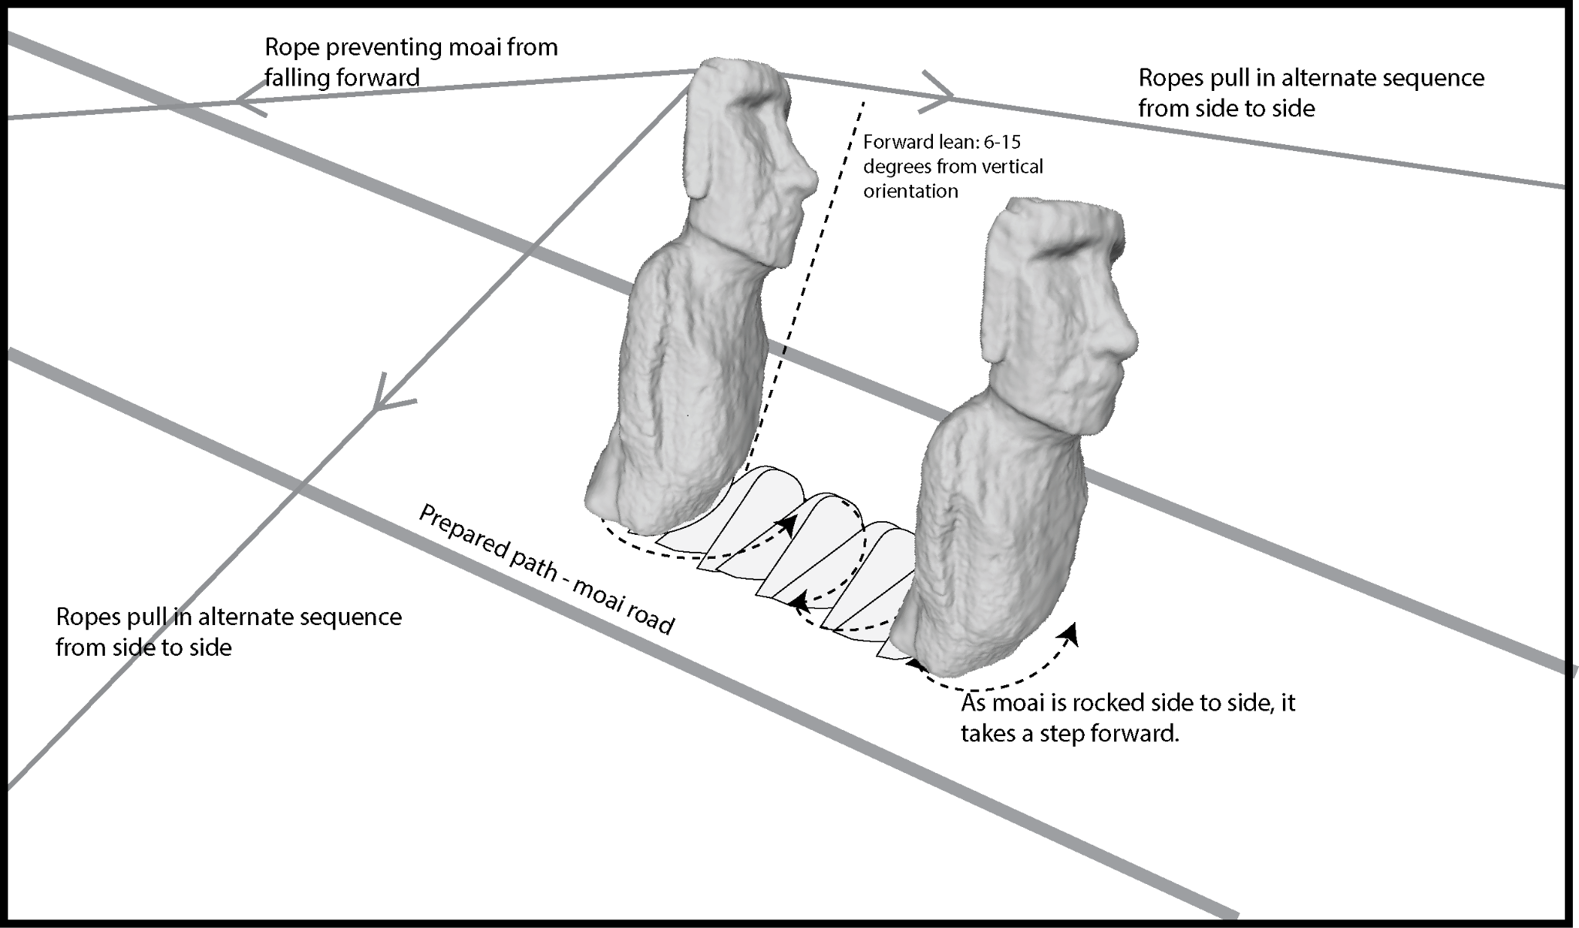
Figure 2. Schematic representation of the moai transport method using coordinated rope pulling. The diagram illustrates the "walking" technique whereby moai were moved along prepared roads through alternating lateral rope pulls while maintaining a forward lean of 5-15 degrees from vertical. A restraining rope prevents forward toppling as side ropes create a controlled rocking motion that advances the statue with each oscillation. The movement of the moai follows a characteristic zig-zag path created by this side-to-side stepping motion.
Notably, the Native Rapanui community has for centuries enthusiastically embraced this understanding of their ancestors' remarkable engineering achievements. Indeed, a widely known moai walking song recounts an early ancestor, Tu`u Ko Iho, who, as the lyrics tell, knew how to make the statues walk. Like traditional working songs worldwide, it shares striking musical features that serve practical functions in coordinating labor. Work songs feature a pronounced, steady rhythm with a tempo and beat tailored to match the pace of repetitive tasks, thereby synchronizing workers’ movements, such as pulling lateral ropes. Today’s moai walking song reflects the persistence of ancient cultural memory. Moai walking was recently celebrated with a performance of the song during Tapati Rapa Nui, the island's premier cultural festival, where reenactments of the transport of vertical statues were a highlight of the celebrations. Such moai walking reenactments are regularly celebrated in cultural performances on the island today. The islanders have reclaimed their narrative of ingenuity rather than one of failure with ecological collapse (Diamond 2005). The integration of walking moai into cultural performances reflects a dedication to preserving and celebrating authentic Rapa Nui traditions. It represents the community's recognition that this method aligns with their oral histories and cultural knowledge.
Yet, despite widespread acceptance and the convergence of archaeological, experimental, and ethnographic evidence supporting vertical transport, more than a decade later, some scholars continue to reject the walking hypothesis without offering falsifiable alternatives or addressing the comprehensive evidence we presented. This situation exemplifies Kuhn’s insight into scientific resistance to paradigm shifts. The walking hypothesis challenges not only transport mechanics but the broader narrative of Rapa Nui as an ecological cautionary tale. As Kuhn (1962) noted, “normal science” often forces new evidence into old frameworks, while Popper (1962) emphasized that science advances by testing and rejecting falsified theories. The issue is not whether scholars prefer horizontal or vertical transport, but which hypothesis better explains the archaeological evidence and withstands experimental scrutiny. This approach is at the heart of archaeological research. As Perreault (2019, p. 8) notes, “archaeologists test hypotheses all the time: every component of an archaeological interpretation is a hypothesis that is vulnerable to testing.” Of course, to be productive, hypotheses must be framed in a way that allows for them to be wrong, and our goal is to seek strong, discriminating evidence rather than relying on unfalsifiable or weakly testable claims. In the case of moai transport, we have that discriminating evidence. However, it does not fit a narrative of environmental collapse driven by statue transport, which required the use of thousands of trees for wooden rollers. Instead, it points to sustainable practices in which statues were moved upright using simple physics and teamwork—a resourceful solution, not an environmentally destructive one.
In this review, we aim to achieve two goals. First, we consolidate the theoretical and empirical foundations supporting moai walking, drawing on twelve years of additional research, refined experiments, and new archaeological discoveries. Second, we systematically address each published critique, demonstrating how these objections fail to meet the basic criterion of scientific discourse: falsifiability. Our goal is not merely to defend our hypothesis but to follow Laplace's principle (1902, p. 17), that “the weight of evidence for an extraordinary claim must be proportioned to its strangeness.” In this case, the extraordinary evidence supports the extraordinary claim that multi-ton statues walked. In our research, we subjected the walking hypothesis to experimental tests, creating conditions where failure was possible. Indeed, we failed to initiate movement and dropped our replica statue multiple times before successfully transporting it. Meanwhile, critics offer no comparable experimental validation, no falsifiable predictions, and no comprehensive explanation for the archaeological evidence.
The critics we address—Bahn, Flenley, Van Tilburg, Diamond, Velasco, Richards, Cauwe, and De Dapper—represent established voices in Pacific archaeology. Their objections deserve serious consideration, yet as we demonstrate, none provide falsifiable alternatives or address the convergence of evidence supporting vertical transport. Their critiques fail Popper's (1962) fundamental test: they cannot specify what evidence would convince them their positions are wrong while simultaneously ignoring evidence that contradicts their claims.
Here, we offer both a vindication of experimental archaeology and a case study of scientific resistance to paradigm change. We begin by establishing the empirical foundation for walking transport, drawing on an analysis of nearly 1,000 moai with a focus on 62 statues that were abandoned during transport. We then address each published critique, applying Popper's criterion of falsifiability to each. The moai walked—the evidence is carved in stone, validated through experiments, and celebrated in contemporary Rapa Nui culture. The question is why some scholars, despite claiming allegiance to scientific principles, still refuse to accept this model for the transportation of moai.

1.1 Archaeological Evidence
Our comprehensive study analyzed 962 moai across the island, representing the most extensive systematic documentation of the Rapa Nui statuary to date. This database, compiled through field surveys and photogrammetric documentation, includes statues from multiple contexts, such as quarries, roads, and ceremonial platforms (Hochstetter et al., 2011). Of particular significance are 62 statues documented along ancient transport roads, abandoned where they fell at various points of their journey from the Rano Raraku quarry. These road moai, preserved in their transport configuration, provide crucial evidence for understanding prehistoric moving techniques (Lipo et al., 2013; Lipo and Hunt, 2005).
The road moai were identified through several criteria establishing their in-transit status. Each statue lies adjacent to road alignments that radiate from Rano Raraku, oriented in directions consistent with movement away from the quarry. Their distribution along roads, combined with evidence of transport failure such as breakage patterns, confirms that these represent abandoned transport attempts rather than deliberate installations.
Analysis of these road moai reveals three distinctive morphological characteristics that differentiate them from statues successfully erected on ceremonial platforms (ahu), pointing to purposeful engineering for transport (Figure 2). First, road moai possess significantly wider bases relative to shoulder width compared to ahu moai. Our quantitative morphometric analysis documents this relationship precisely: road statues exhibit a shoulder-to-base width ratio approaching 1.0, meaning the base width nearly equals the shoulder width. This arrangement creates a broadly stable foundation with the mass distributed low on the statue. In contrast, platform statues show ratios consistently exceeding 1.0, with shoulders wider than bases, creating a more top-heavy configuration. This modification occurred after transport, when carvers reduced the base width to achieve the aesthetic proportions desired for display, while also enabling stable upright positioning on level ahu surfaces. The wider bases of road moai serve a critical functional purpose: they lower the center of mass and provide the lateral stability essential for the side-to-side rocking motion of walking transport (Figure 3). The broad base acts like the rounded bottom of a bowling pin, allowing the statue to rock significantly without toppling sideways.
Second, road moai exhibit a pronounced and consistent forward lean, typically ranging from 6° to 15° from vertical. This forward lean positions the center of mass close to or even slightly beyond the front edge of the base, a configuration that renders independent standing impossible without support (Figures 4 and 5). Three-dimensional modeling confirms that this forward displacement of mass is not incidental but carefully engineered. When tilted laterally during transport, this forward lean causes the statue to fall forward in a controlled manner, with the rounded front edge of the base acting as a pivot point for forward rotation. Each lateral rocking motion thus produces a forward "step" as the statue rolls along its front edge. Platform moai, once they reached their destinations, were substantially modified through base reshaping to eliminate this lean. Carvers removed material from the front of the base and added support at the rear, shifting the center of mass back over the base center to achieve stable upright positioning. Tailings of Rano Raraku volcanic tuff from moai and found in ahu platforms provide the physical signature of this step in the process (S. Rapu, personal communication, 2011). The transformation of moai form from transport-enabled to platform-ready was critical, yet this distinction had gone unnoticed among most archaeologists.
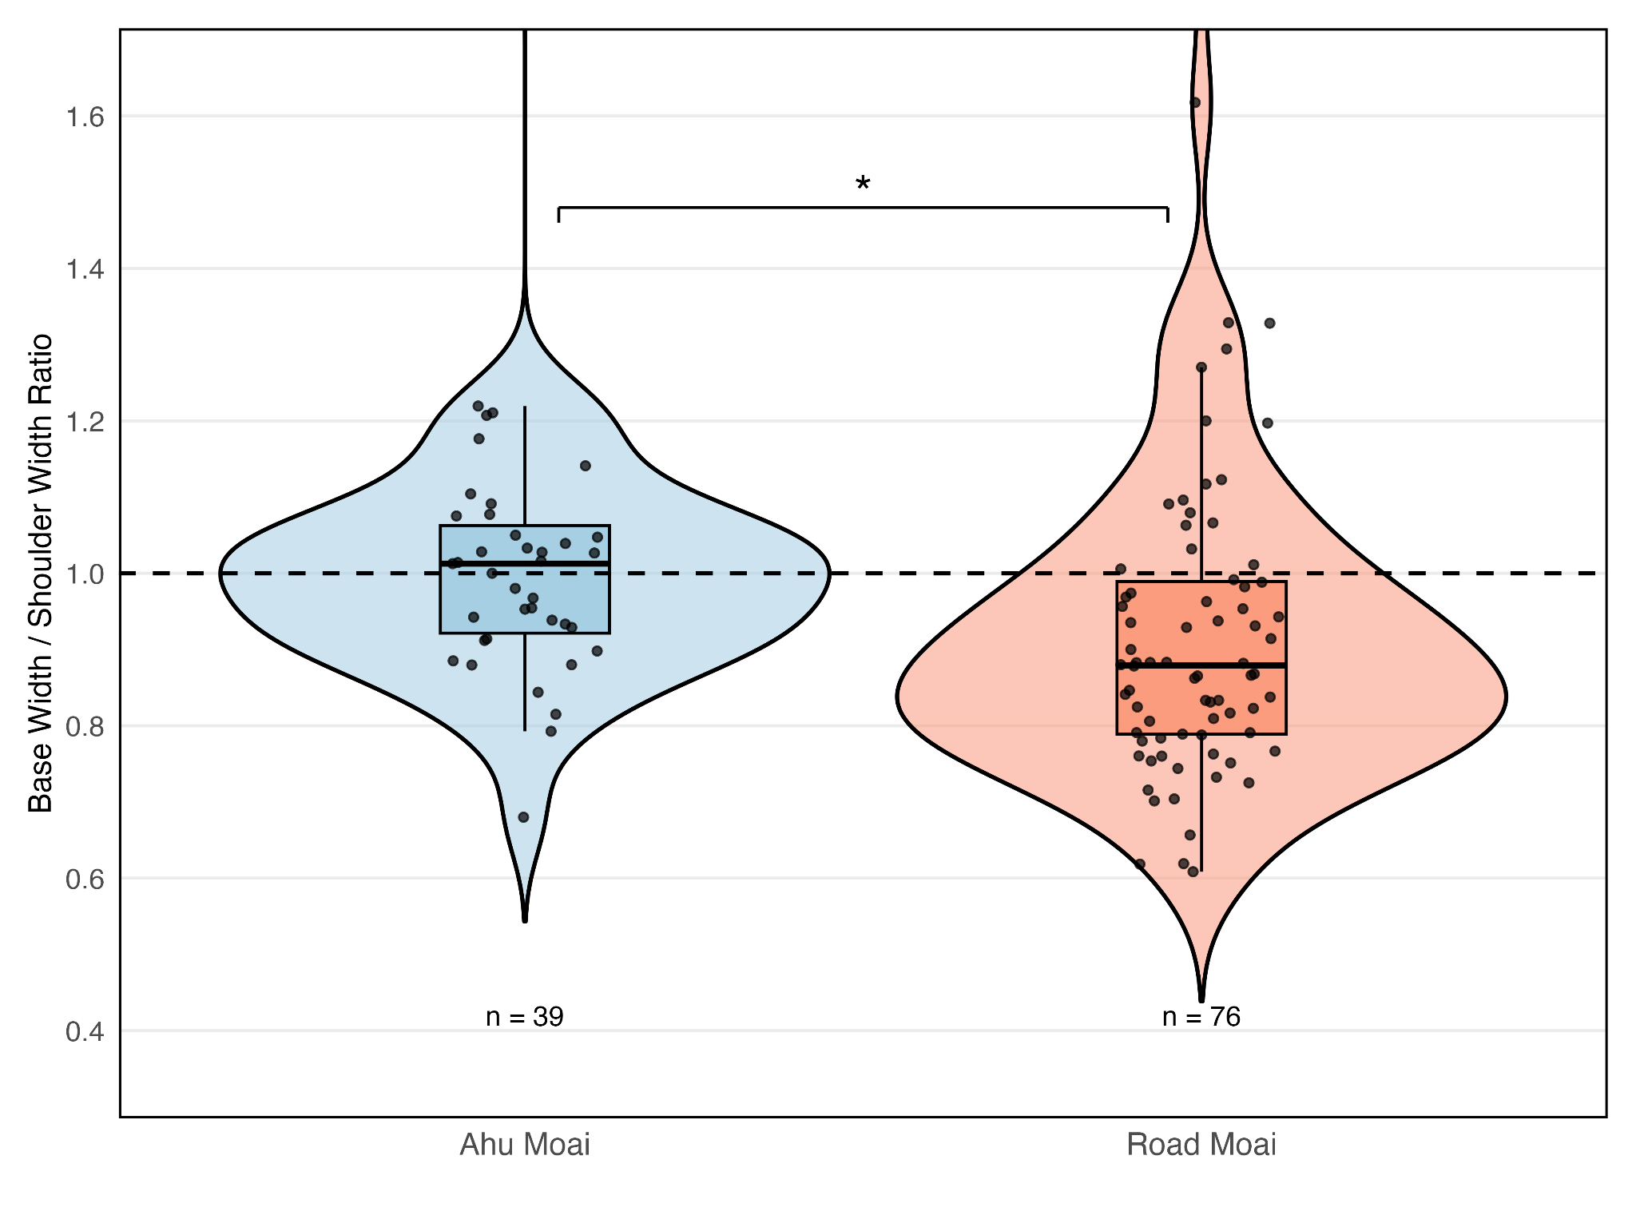
Figure 2. Comparison of the ratio of base width to shoulder width for ahu moai (left) and road moai (right). Using measurement data of moai from Van Tilburg (1986), the figures show that the two types of moai have statistically distinctive ratios (t = 2.474, df = 86.0, p = 1.532e-02).
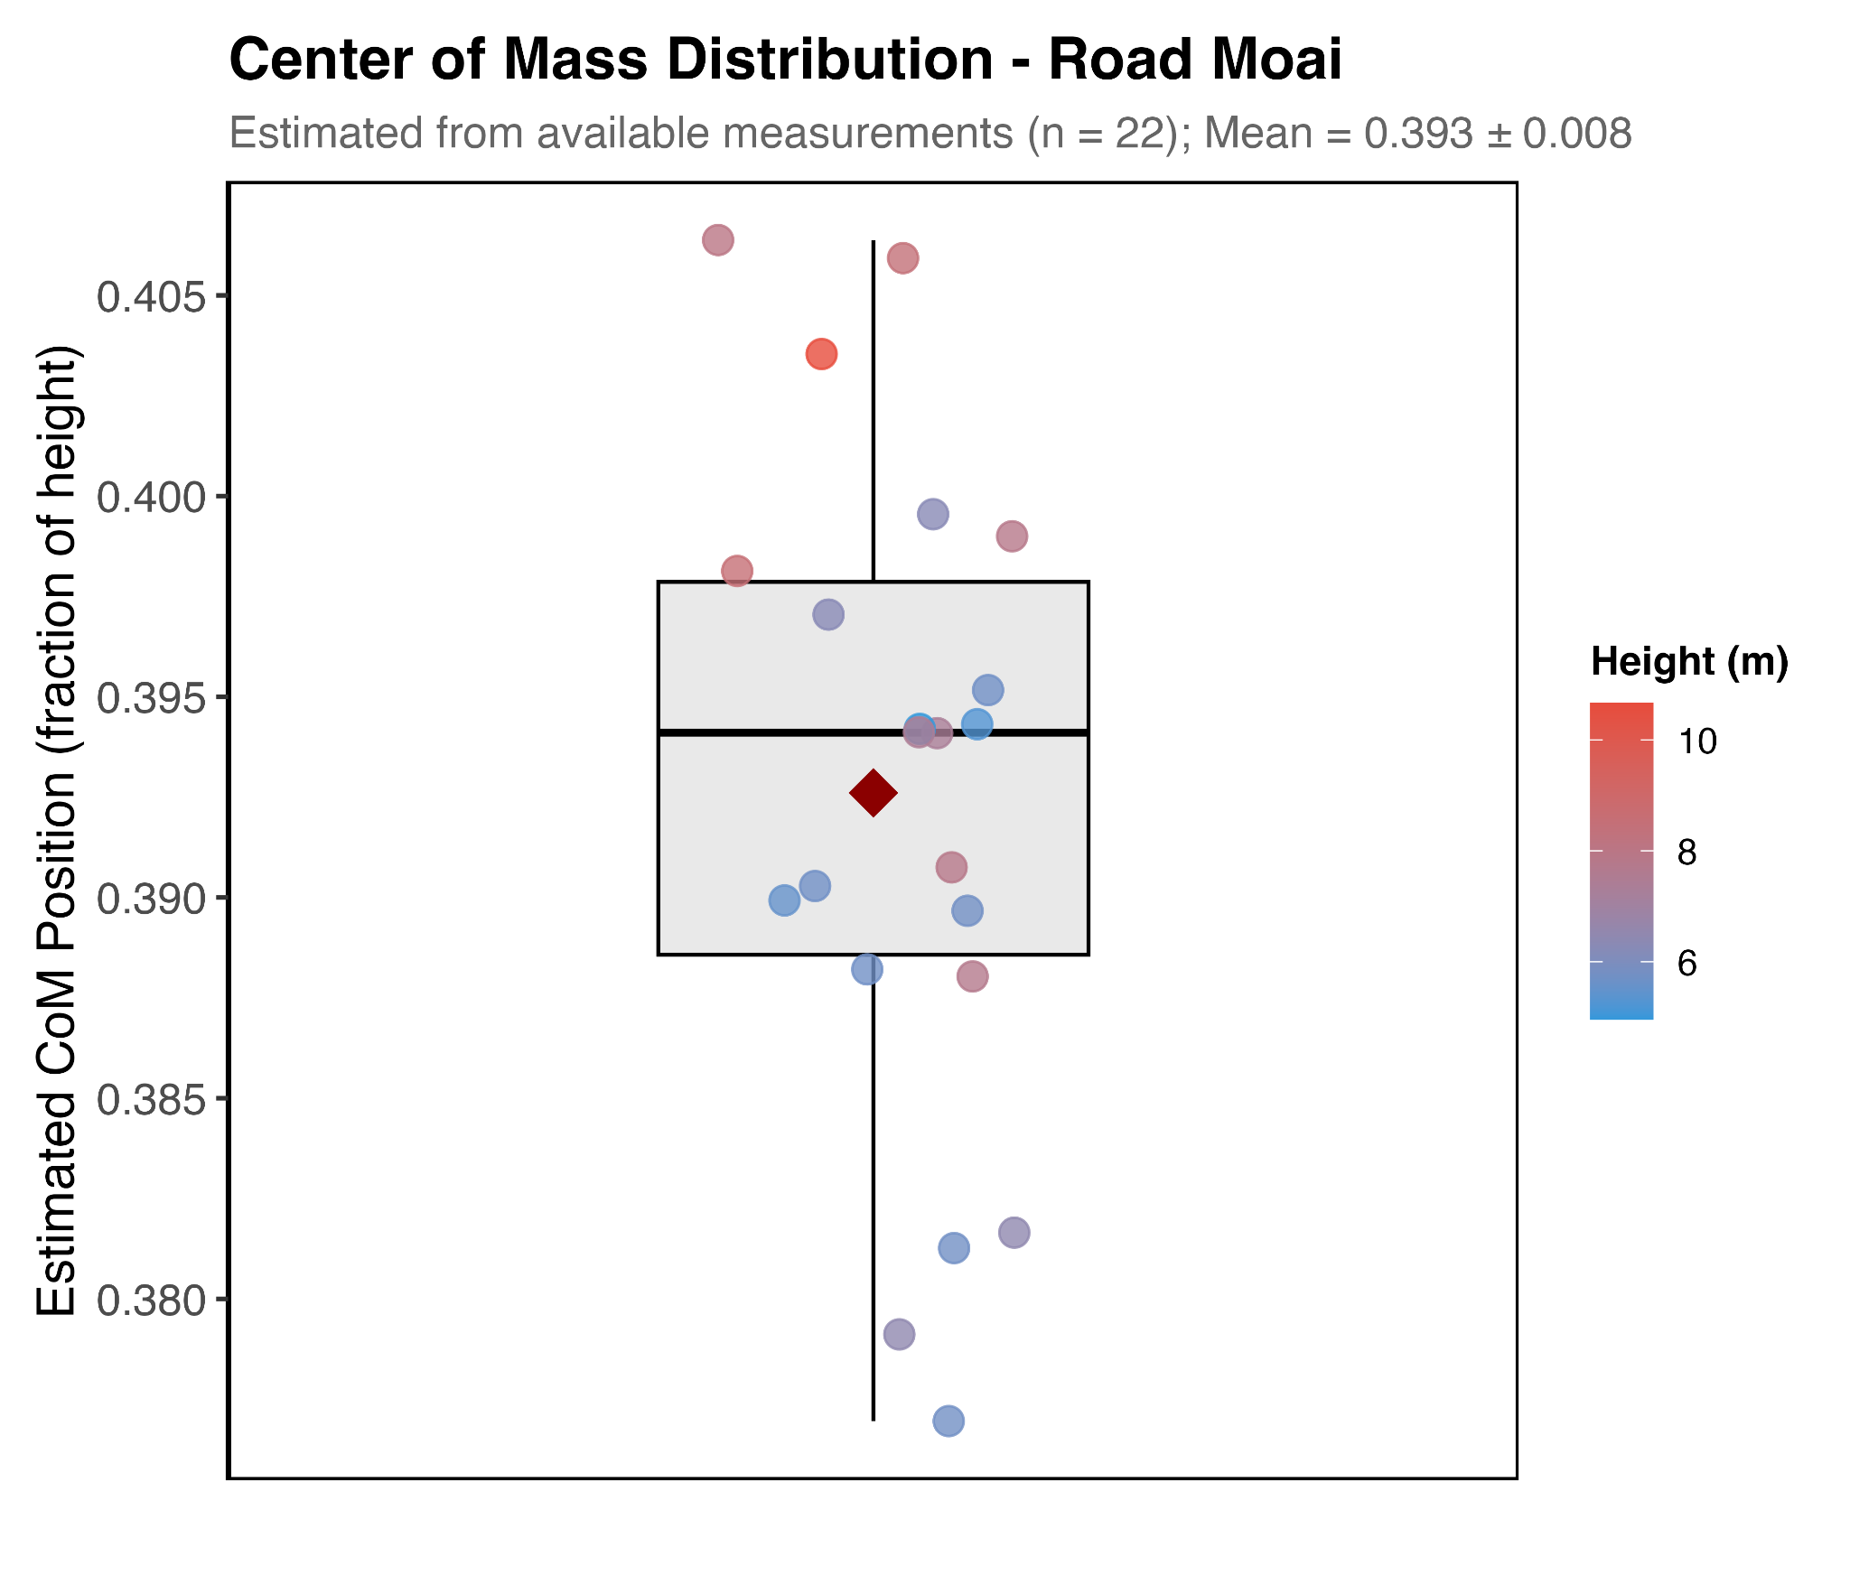
Figure 3. Center of Mass Calculation (CoM) for Road Moai (n=22). CoM positions were estimated from Van Tilburg's (1986) data using a volumetric sectional analysis based on available morphometric measurements (total height and base width, with shoulder width when available). Our analysis divided each moai into four anatomical sections (base: 20%, belly: 35%, chest: 25%, head: 20%) with assumed elliptical cross-sections and depth estimated at 50% of the width for body sections and 60% for the head section. Individual moai are represented as points colored by height, with a box plot indicating the median, quartiles, and range. The mean CoM position (red diamond) of 0.393 ± 0.009 (fraction of total height from base) indicates all road moai have centers of mass well below the midpoint (0.5), consistent with the stability requirements for oscillatory walking transport. Due to limited measurement data and necessary geometric assumptions, actual CoM positions may vary by ±5-10% from these estimates. More precise determination would require three-dimensional scanning or additional morphometric measurements, including depth profiles and intermediate width measurements along the moai body.
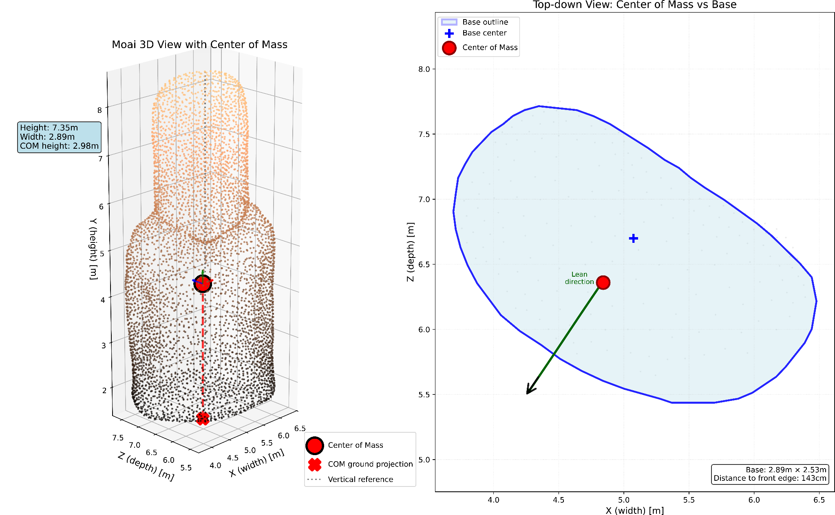
Figure 4. Center of mass analysis of a Rapa Nui moai 3D model. (Left) Three-dimensional visualization of moai 12-220-01 showing the moai mesh (n = 5,150 vertices) colored by height, with the center of mass indicated by a red sphere located at 40.6% of the statue's total height (2.98 m above base in a 7.35 m tall moai). The vertical dashed line shows the projection of the center of mass to the base plane. This moai has a forward lean angle of 6.5°. (Right) Top-down view showing the D-shaped base outline (blue) derived from a horizontal cross-section 10 cm above the statue’s base. The center of mass (red circle) is projected within the base footprint, positioned 23.2 cm to the left and 34.0 cm backward from the geometric center of the base (blue cross). A green arrow indicates the lean direction..
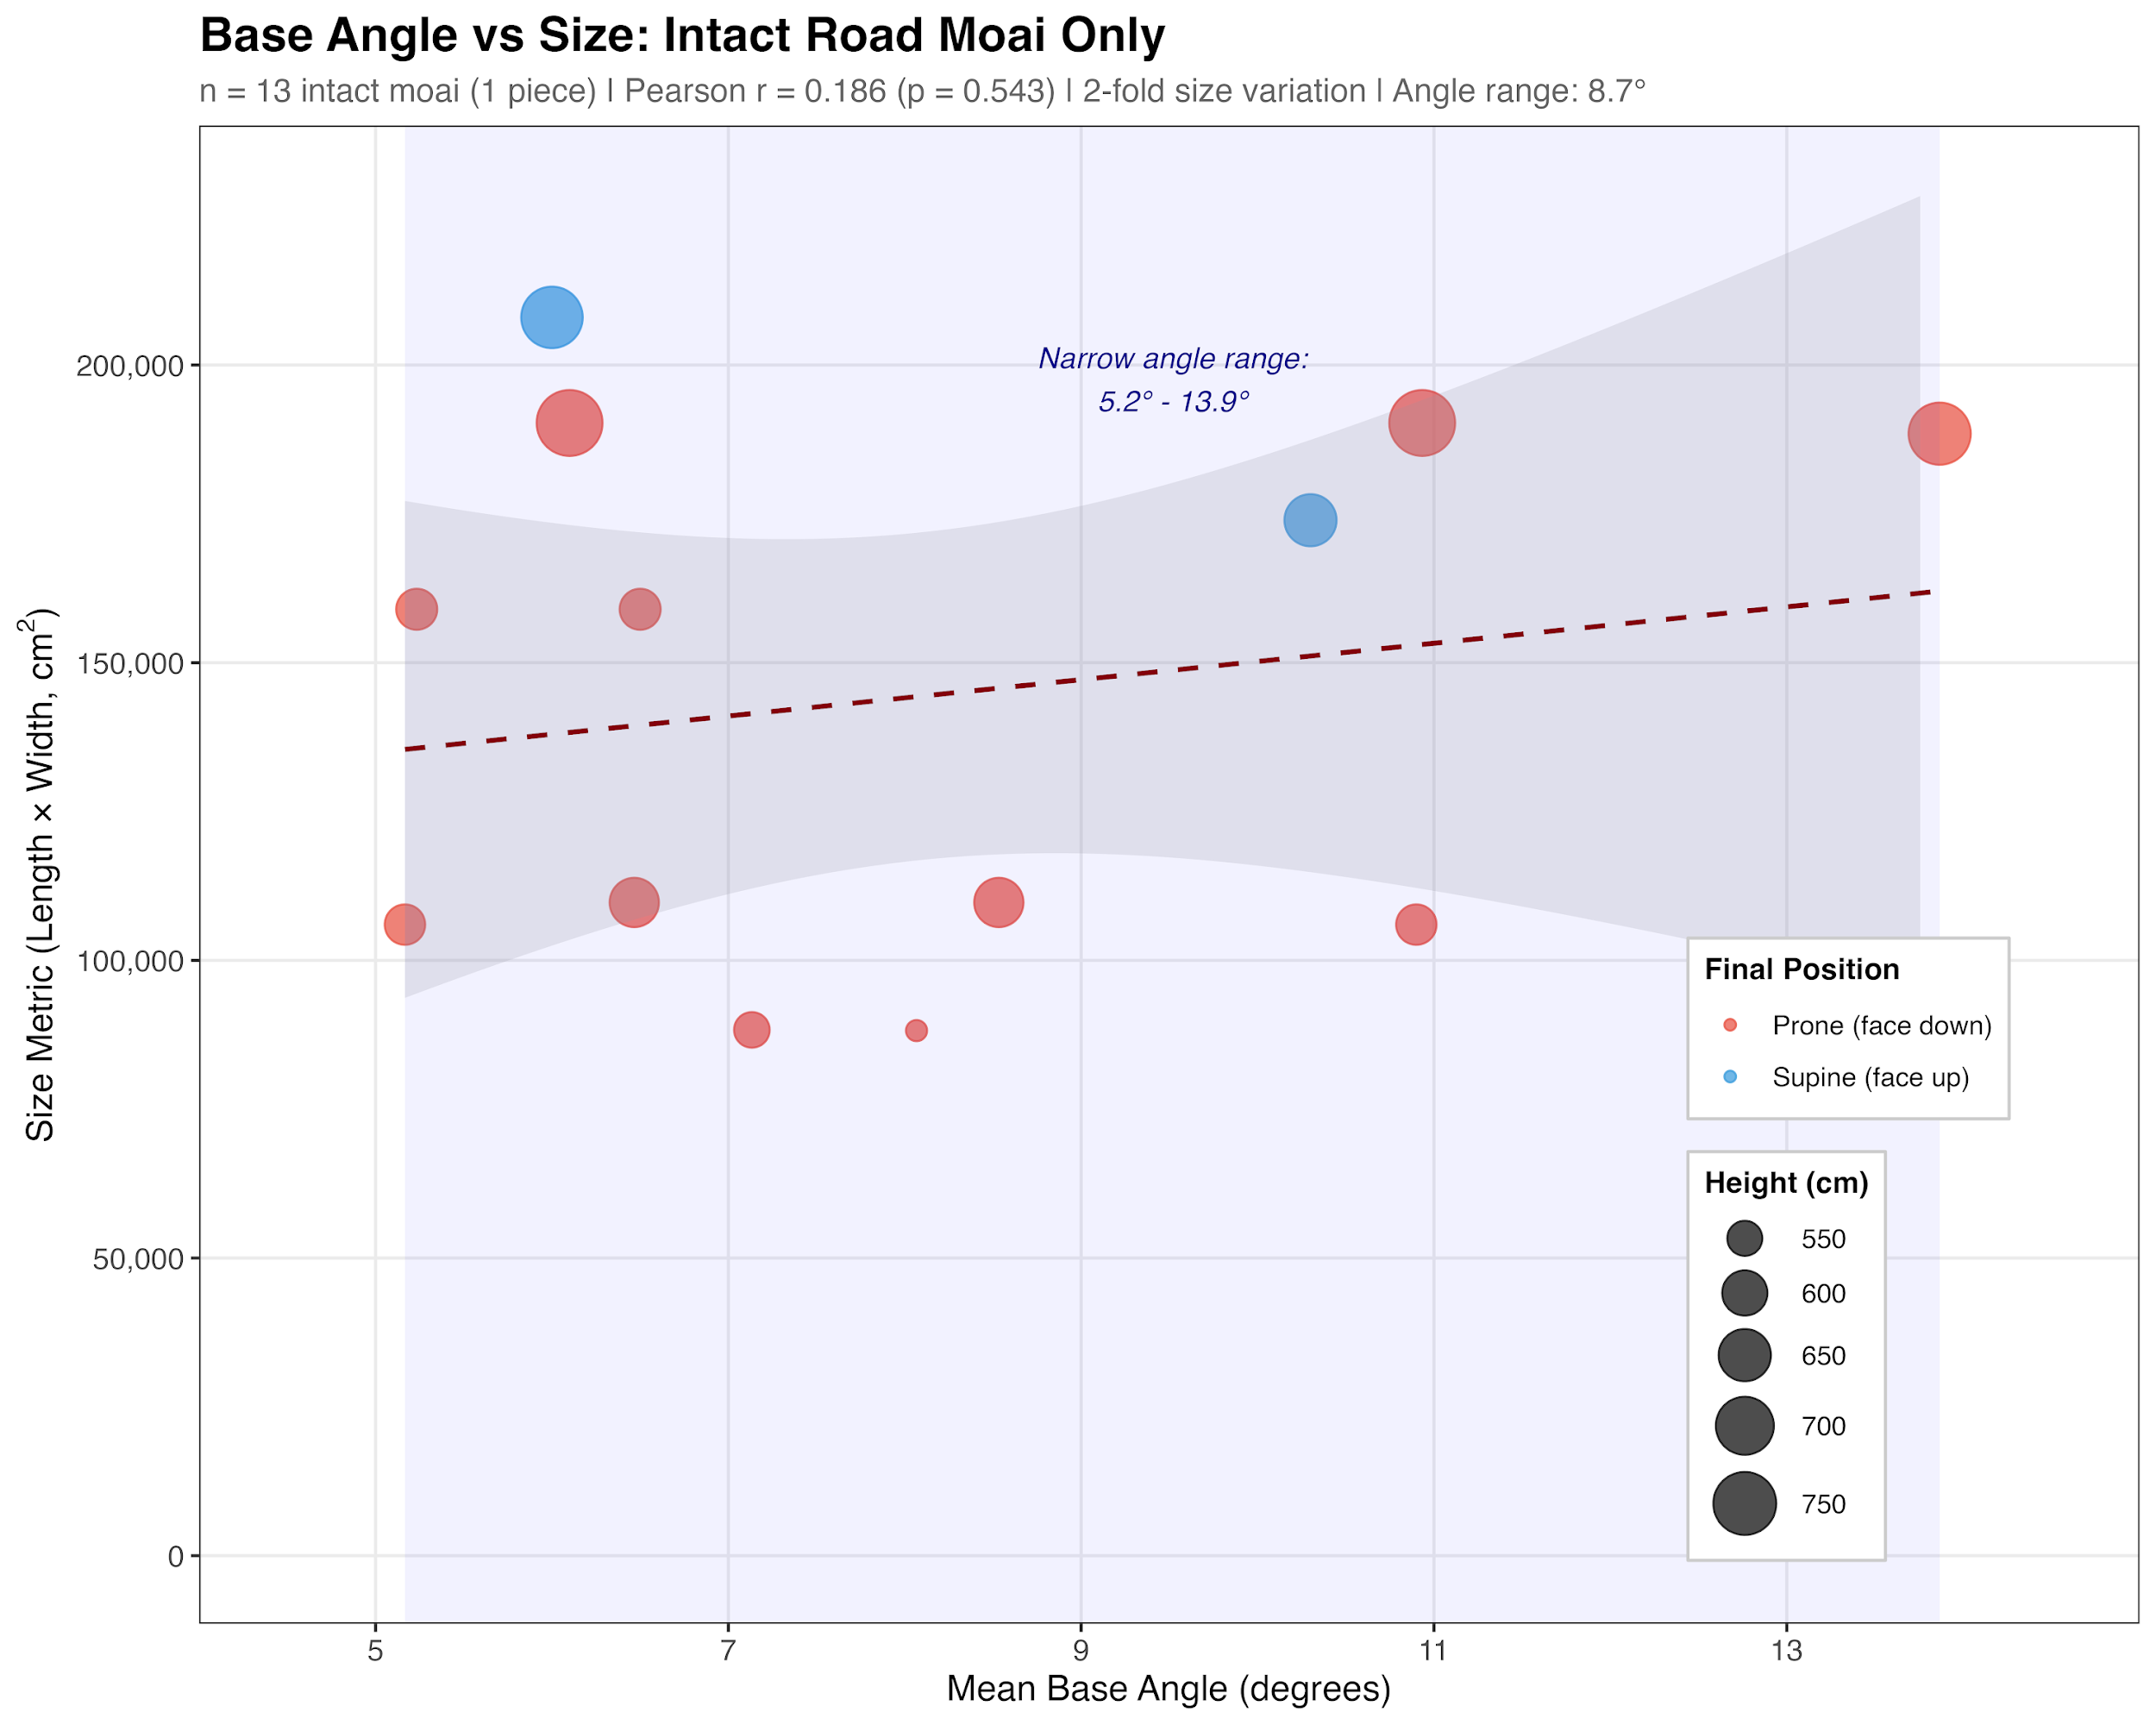
Figure 5. Relationship between moai base angle and size metric (total length × base width) for intact road moai (n = 13). Using data from Schumacher (2013) and additional measurements of moai basal angles, the figure displays individual moai, with point size proportional to moai height (in cm) and color indicating their final resting position (red = prone/face down, blue = supine/face up). The dashed line represents the linear regression fit, along with its 95% confidence interval (shaded area). A weak positive correlation (Pearson r = 0.186) was observed between the base angle and size metric, suggesting that the base angle construction was relatively standardized across the size range of the transported moai. The narrow range of base angles (~5-14°) despite substantial variation in moai size (approximately 50,000-200,000 cm²) supports the hypothesis that a specific angle range was optimal for the walking transport method. The data represent only intact moai found along the ancient roads, excluding fragmented specimens.
Third, road moai uniformly lack carved eye sockets, a definitive indicator of their incomplete ceremonial status. In the Rapa Nui tradition, the eyes (mata) were not merely decorative but spiritually transformative elements that activated the mana (spiritual power) of the ancestors represented by the moai. Ethnographic accounts and archaeological evidence confirm that eyes were carved only as a final step after the statue’s successful erection on the platform. These sockets were designed to hold white coral eyes with obsidian or red scoria pupils, creating a striking gaze that overlooked ceremonial spaces. The insertion of eyes, often accompanied by the placement of red scoria hats (pukao) on larger statues, marked the transformation from carved stone to living ancestor, denoted by the phrase “oringa ora o te tupuna” in the Rapanui language. The complete absence of eye sockets on all 62 documented road moai confirms these statues never reached the ritual completion stage. This pattern holds even for unbroken road moai that lay near ahu platforms, indicating that proximity to a ceremonial site was insufficient—only successful erection triggered the final transformation.
The wide bases with a low center of mass and engineered forward lean worked in tandem to enable vertical transport. The absence of eye sockets signaled that the moai was not yet complete. The morphology is not accidental but rather represents sophisticated engineering adapted to the available technology and landscape challenges. The consistency of these features across road moai, regardless of size or location, indicates standardized production methods optimized for walking transport.

1.2 Road Infrastructure
Archaeological investigations of moai roads reveal a sophisticated transportation infrastructure extending over 25 km from the Rano Raraku quarry (Lipo and Hunt, 2005). These engineered pathways, first documented by Katherine Routledge in 1919, provide critical evidence for understanding the mechanics of transport (Routledge, 1919). The roads maintain consistent dimensions across varied terrain, averaging approximately 4.5 meters in width, sufficient for maneuvering multi-ton statues.
Notably, excavations reveal that the roadbeds have concave cross-sections (Love 2001). This shape would pose significant structural problems for any solution involving wooden rollers or frames that would lie perpendicular to the road. Instead, the consistent concave shape suggests that the statues were purposefully engineered to guide them during transport (Love 2001). Based on our experiments, we found that the concave shape of the roads would help constrain lateral movement during the rocking motion of walking transport.
Gradient analysis along two extensively studied south coast road sections documents the extraordinary topographic challenges overcome by prehistoric engineers. Using UAV photogrammetry, we generated high-resolution topographic profiles for these road paths. As Figure 6 shows, the moai roads represent an engineering solution that made transport feasible by providing the most level routes available. The moai roads provided remarkably level transport corridors, with median slopes of only 2-3% and 95% of the route had a grade of less than 10%. While maximum recorded slopes reach 26%, these occur on less than 0.5% of the route (under 20 meters in total) and are likely to represent localized obstacles or measurement artifacts rather than sustained grades. The 95th percentile slopes, at 9-11%, more accurately represent the actual challenging sections that transport teams would encounter. Based on these data, it appears that the moai roads were engineered transport corridors that utilized the island’s topography. The Rano Raraku to South Coast road, for example, descends 27 meters overall, with 45% of the route consisting of downhill segments where teams could use controlled sliding (as demonstrated at the quarry itself), 34% flat sections for easy walking, and only 21% requiring uphill effort. Rather than obstacles, the steeper downhill slopes likely facilitated transport through controlled descent.
Our walking experiments demonstrated that vertical statues could be navigated on such slopes through controlled stepping. Although not depicted in the televised NOVA documentary, our experiments involved walking a statue up and down slopes as steep as 5% (2.9 degrees) without encountering any problems. We also rotated the moai in place to demonstrate how it could be turned around once it reached the top of an ahu and was ready for positioning.

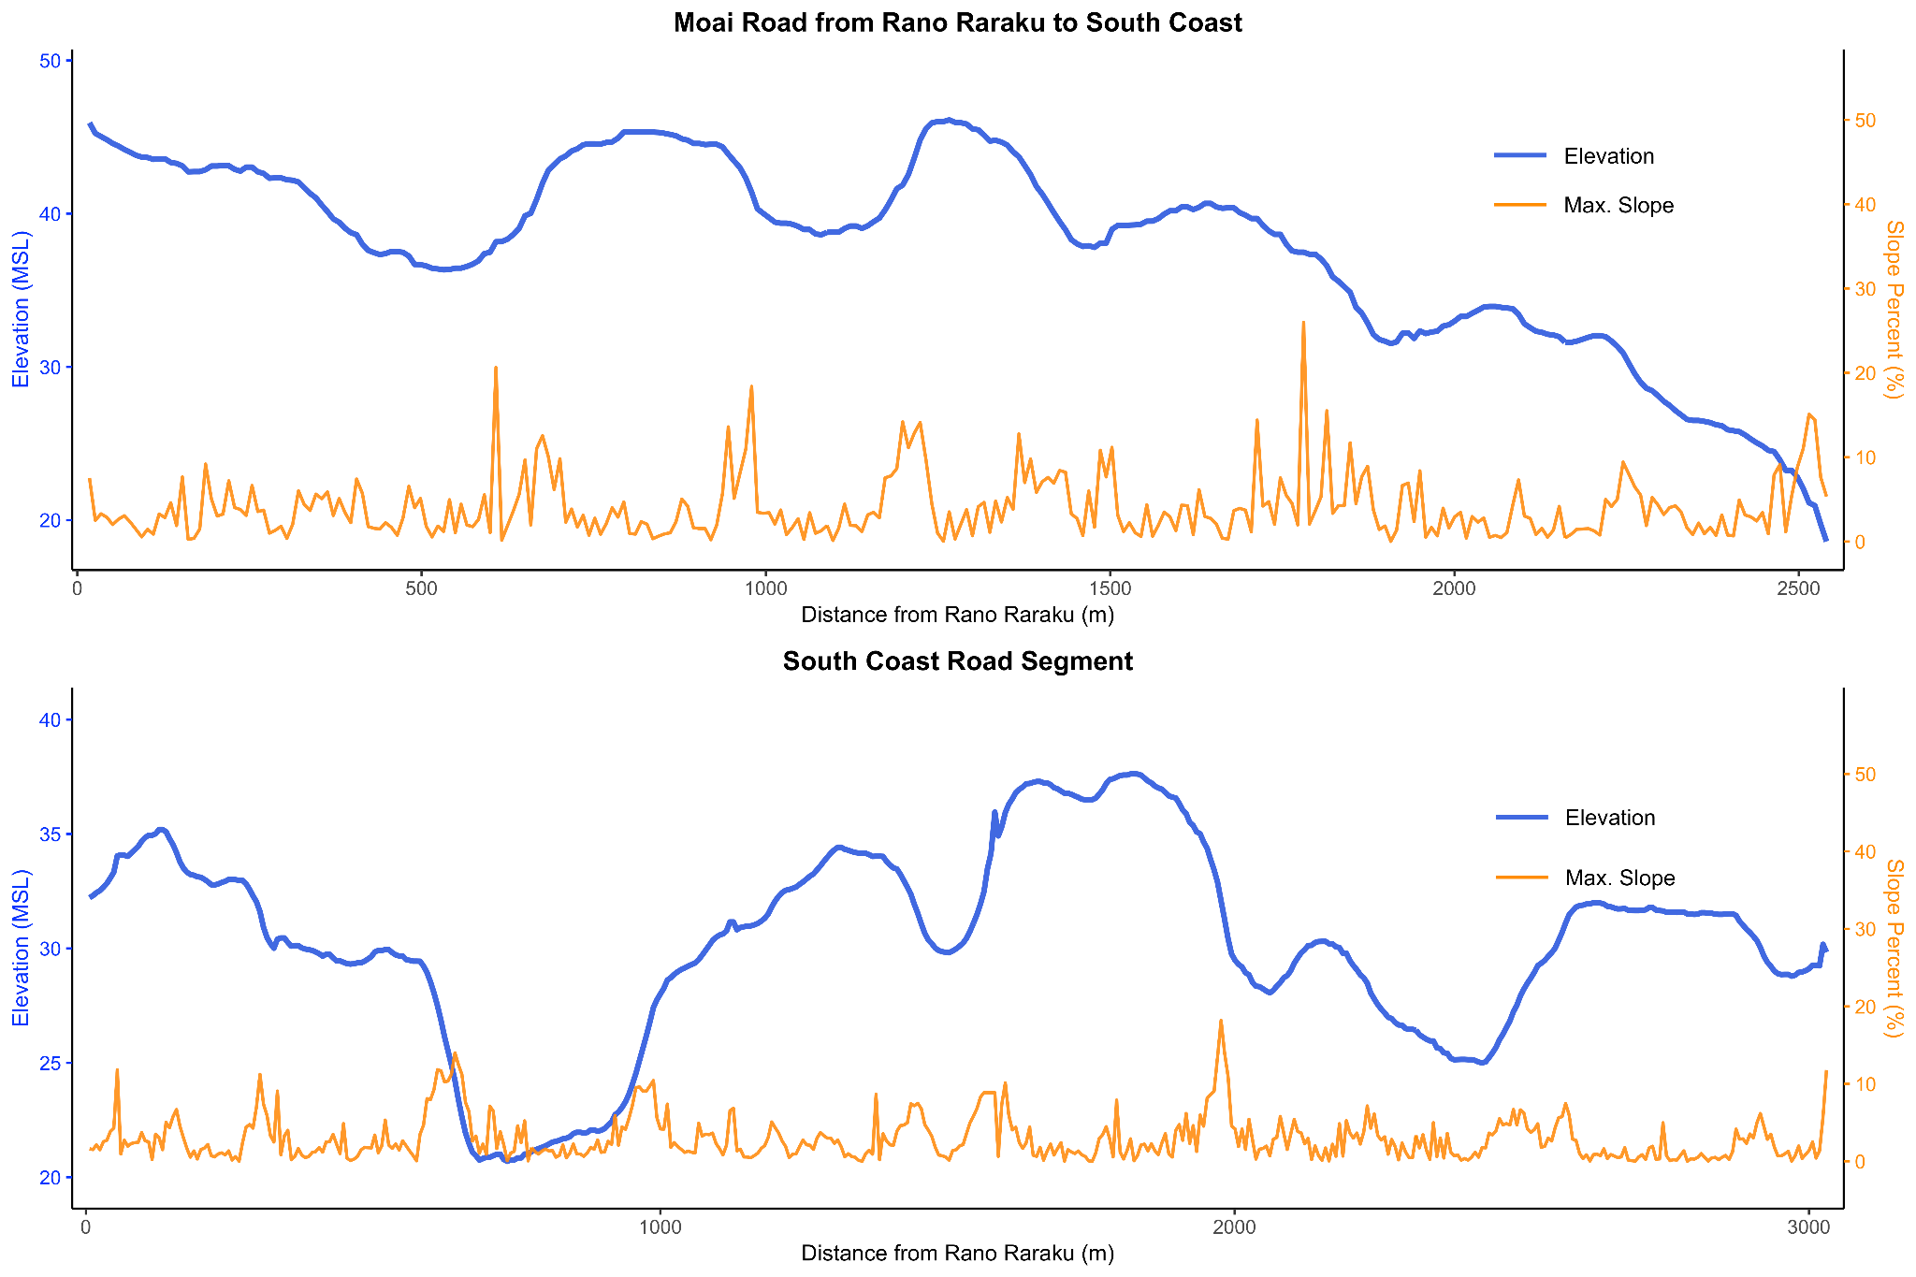
Figure 6. Elevation and slope profiles for moai transport roads documented through low-elevation UAV photogrammetry. (A) The Rano Raraku to South Coast road descends 27.3 meters over 2.5 kilometers, with 45% of the segments suitable for controlled sliding, 34% of the terrain being flat and suitable for walking, and only 21% requiring uphill effort. (B) The South Coast features a road with minimal elevation change and balanced terrain distribution. While maximum slopes of 20-26% occur, these represent less than 0.5% of the routes. Median slopes of 2-3% and means of 3-4% better characterize actual transport conditions. The predominance of favorable terrain (79% downhill or flat on the main road) demonstrates how roads facilitated transport, while the lack of moai concentration at uphill sections (χ² = 1.52, p = 0.47) supports stochastic rather than topographically determined transport failure.
Overall, the form of roads and the absence of modifications necessary for roller or sledge systems across the documented road network, despite preservation conditions that would retain such evidence, also argue against horizontal transport. The roads appear expressly designed for vertical statue movement, with their width, concave profile, and capacity to handle steep gradients, supporting the walking hypothesis.

1.3 Physical Evidence from Failed Transport
The 62 documented road moai represent direct evidence of transport failure, preserving information about movement methods. Our analysis reveals patterns consistent with vertical transport across multiple lines of evidence. Breakage pattern analysis shows that 37% of road moai exhibit breaks consistent with falling from a vertical position. These breaks typically occur at geological weaknesses where bedding planes intersect carved features, producing horizontal fractures through necks or torsos rather than the vertical splitting expected from lateral impacts from horizontal dragging.
Diagnostic evidence comes from patterned base damage. Analysis reveals that 70% of road moai bases exhibit lateral edge fractures appearing as broad, shallow concave scars where pressure flakes detached. These fractures concentrate on lateral edges, precisely where maximum stress would occur during side-to-side rocking motion. The absence of longitudinal scraping or grinding marks, which are typically expected from horizontal dragging, further supports the notion of vertical transport.
Statistical analysis of moai positions relative to road topography provides independent confirmation. The positions of fallen statues are statistically non-random (p < 0.02) with respect to slope: the majority are found face-down when roads slope downhill and frequently on their backs when going uphill. This pattern aligns with expectations for forward-walking statues, where downhill falls result in forward positions, while uphill falls cause backward positions as the statues tip away from the direction of travel.
Table 1. Distribution of road moai positions relative to slope direction, demonstrating non-random orientation patterns consistent with mechanical failure during transport (Hunt and Lipo, 2011, p. 203). Analysis of 51 road moai reveals a significant association between final resting position and slope direction (χ² = 12.388, df = 4, p = 0.0147; Fisher's exact test p = 0.0032). Face-down (prone) moai show preferential orientation on downhill slopes (54.8% downhill vs. 35.5% uphill), while face-up (supine) moai exhibit the opposite pattern, predominantly occurring on uphill slopes (84.2% uphill vs. 15.8% downhill). This inverse relationship yields an odds ratio of 8.24, indicating that face-down moai are over eight times more likely to occur on downhill slopes compared to face-up moai. The medium effect size (Cramér's V = 0.349) and high statistical significance support a systematic, non-random pattern. These orientations align with expected mechanical failure modes during transport: moai being moved downhill would be prone to forward tipping (resulting in face-down position), while those being pulled uphill would more likely fall backward (resulting in face-up position).
 |  | Direction of Slope Relative to Moai
 |  | Downhill | Flat | Uphill | Total
Moai Position | Face Down | 17 | 3 | 11 | 31
 | Face Up | 3 | 0 | 16 | 19
 | Lateral | 0 | 0 | 1 | 1
 | Total | 20 | 3 | 28 | 51
Two examples along the South Coast Road preserve evidence of ancient attempts at re-erection. At these locations, unbroken moai protrude, partially buried with their bases below ground (Figure 7). A fallen statue could be brought back to a vertical position by excavating under the lower portion, thus enabling an adequate angle to right it with ropes. These re-erection attempts demonstrate that statues were transported upright; horizontal statues would require entirely different recovery methods.
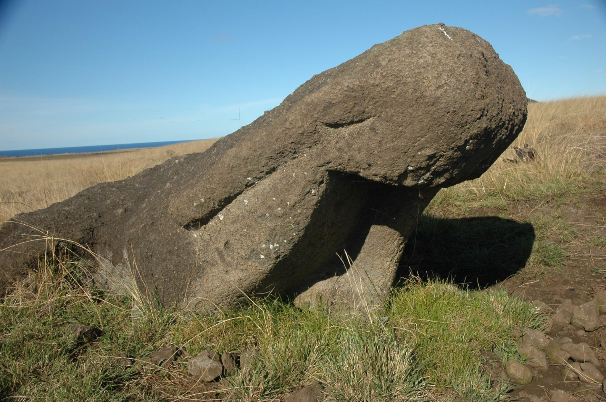
Figure 7. Example of a road moai (south coast) that fell and was abandoned after an attempt to re-erect it by excavating under its base, leaving it partially buried at an angle.

1.4 Three-Dimensional Modeling and Experimental Validation
Using photogrammetric techniques, we created precise 3D models of road moai, revealing crucial engineering features. The models confirm that road moai exhibit a pronounced forward lean, often exceeding 10°, which positions the center of mass close to or slightly beyond the front edge of the base. This engineered instability prevents the statue from standing independently but facilitates forward motion when it is tilted from side to side.
For experimental validation, we used structure-from-motion software to produce a precisely scaled replica based on road moai 12-220-01, located 3.54 km from Rano Raraku along the south coast moai road. The original statue stands 7.35 m tall and 2.83 m wide. Our concrete replica, scaled for practical experimentation, weighed 4.35 metric tons and retained the same proportions and mass distribution as the original. The concrete also included expanded polystyrene additives to achieve the specific gravity of the Rano Raraku tuff.
Experimental trials yielded quantitative validation of the walking hypothesis (Figures 8 and 9). With a minimum crew of 18 individuals, four on each lateral rope and ten on the rear rope, we successfully achieved walking motion. The statue could be tilted laterally as much as 26° from vertical before the risk of toppling sideways, providing substantial clearance for the stepping motion. Through coordinated rope work in one continuous effort, we achieved sustained forward movement of 100 meters in just 40 minutes.
The walking mechanism operates through pendulum dynamics. Once the rocking motion is initiated, the statue’s oscillation requires minimal energy input to maintain, with rope handlers primarily providing guidance rather than motive force. The forward lean causes each lateral tilt to produce forward movement as the statue rolls across its curved front edge.
Our experiments revealed that movement in a vertical walking motion is not only possible but remarkably efficient. Unlike horizontal dragging methods, which require a constant high-force application and risk damage to the statue, the walking method conserves energy through pendulum motion. It minimizes friction between the base and the ground. The rapid transport rate achieved—100 meters in 40 minutes—suggests statues could have been moved several kilometers in a matter of weeks, requiring only modest-sized work crews rather than the massive labor forces assumed by horizontal transport hypotheses.
The scaling properties of the walking method indicate that larger statues would not be proportionally more difficult to transport, as increased height provides greater leverage for rope teams. This explains how the ancient Rapanui successfully moved statues that were over 10 meters tall, weighing approximately 74 metric tons, over distances exceeding 5 km. These achievements would be challenging using horizontal methods, but are perfectly congruent with the walking technique we demonstrated.
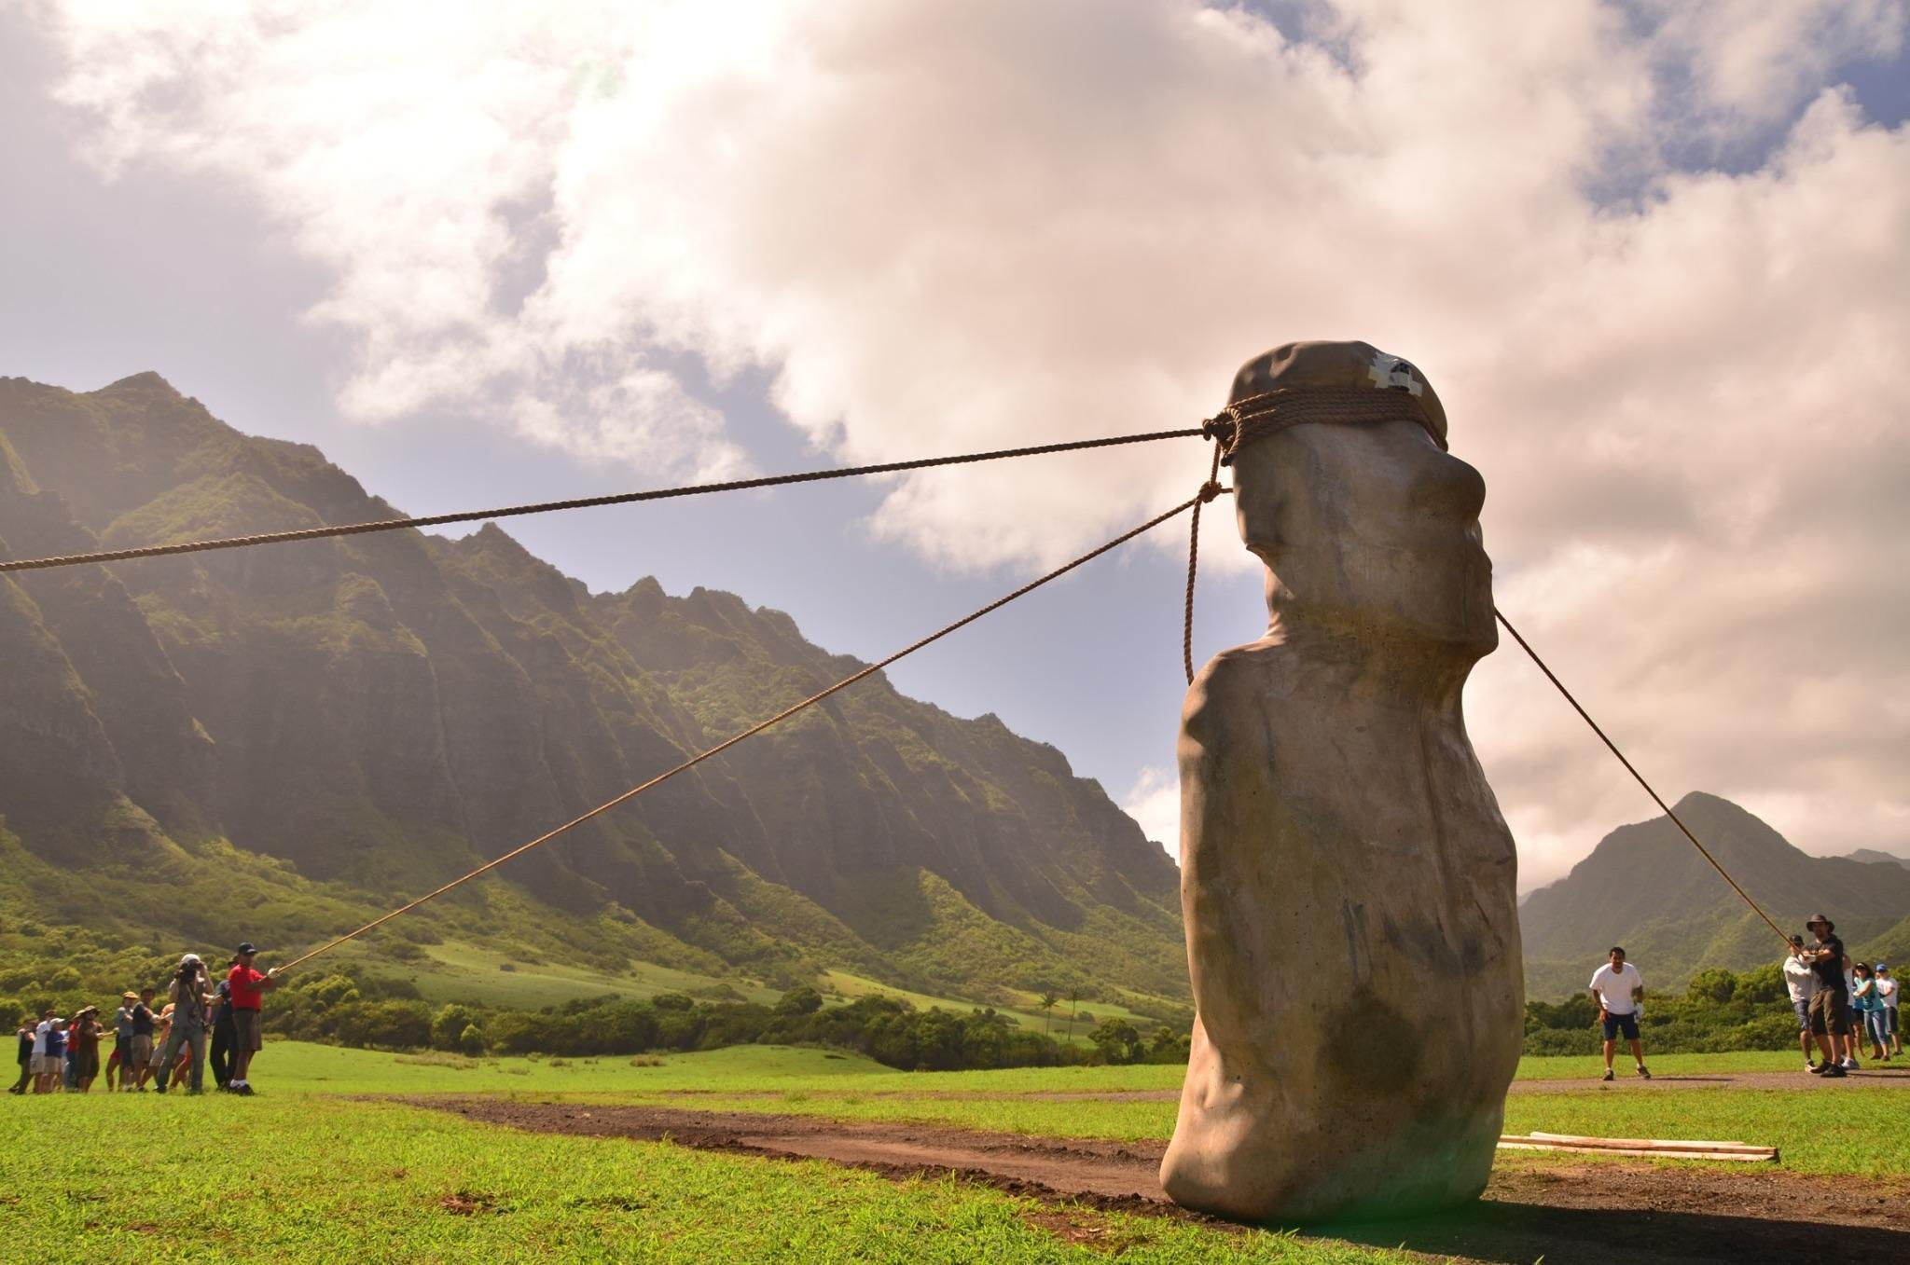
Figure 8. Our 2012 experimental moai transport demonstration, showing the rope configuration for the 4.35-ton replica statue using the "walking" method. One rope is attached to each side of the replica to generate the alternating rocking motion. A third rope, secured to the back of the statue, serves a dual function: preventing forward toppling during the rocking sequence and allowing operators to pull the moai backward for positional adjustments. This three-rope system enables the controlled manipulation of the statue's center of gravity, allowing for forward locomotion through coordinated lateral oscillations.
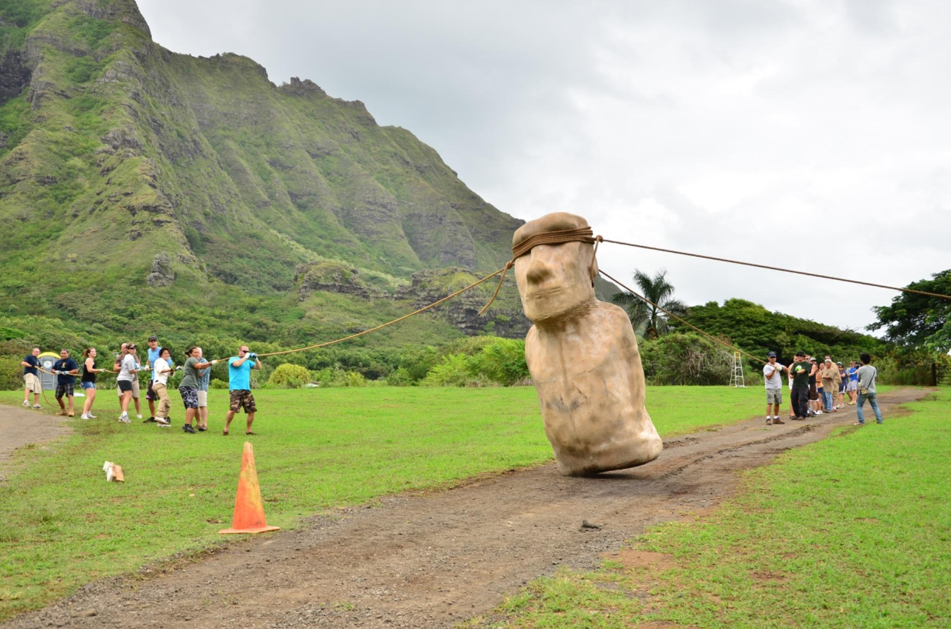
Figure 9. Moai walking in progress. The replica's forward-leaning posture is crucial to the method: as participants rock the statue from side to side using ropes, the forward center of gravity converts each lateral movement into a step-like advance along the path.

1.5. Workforce Requirements for Moai Transport
To understand the human resources required for moai transport, we developed a physics-based model incorporating mass estimation, force calculations, and workforce requirements. Our approach builds on our experimental archaeology and quantitative analysis of labor requirements across the full range of moai sizes.
We calculated the mass of moai using dimensional analysis and material properties. We estimated volume using the formula
Eq. 1. $V=h×\underline{w}×\underline{d}×φ$
where h is height, w̄ is average width (70% of base width), d̄ is average depth (50% of width), and φ is a shape factor (0.65) accounting for the irregular moai form, including concave backs, narrowing at the neck, and facial features. Mass was then calculated using the specific gravity of Rano Raraku tuff (1.86 g/cm³), determined through laboratory analysis of quarry samples (Gioncada et al., 2010). This relatively low density—compared to typical volcanic rocks, which range from 2.5 to 3.0 g/cm³—represents a significant advantage for transport.
The force needed to initiate moai rocking was calculated based on overcoming static friction at the base. Following classical mechanics (Halliday et al. 2013), the minimum torque ($τ_{min}$) required is
Eq. 2. $τ_{min}=μ_{s}×m×g×r$
where $μ_{s}≈0.6$ (coefficient of static friction for stone on the ground), m is mass, g is gravitational acceleration, and r is the moment arm (approximately $\frac{w}{4}$ for a rocking motion).
Critically, our model recognizes that teams would not attempt to reach full rocking amplitude immediately. Instead, like pumping a swing, they would build oscillation amplitude gradually through resonance (French, 1971). This approach significantly reduces the initial force requirement, as teams only need to overcome static friction to initiate minimal movement. With ropes attached at eye level (approximately 85% of moai height), the mechanical advantage ($F_{rope}$) is:
Eq. 3. $F_{rope}=\frac{τ_{min}}{h_{rope}}$
where $h_{rope}=0.85×h_{total}$. The 20-30 meter rope length creates an approximate 30° angle to horizontal, yielding a mechanical efficiency factor of cos(30°) ≈ 0.87.
For workforce calculation, we assumed each person could sustain approximately 400N (40 kg-force) in coordinated pulling, a conservative estimate based on ergonomic studies (Chaffin et al., 2006). The number of people required per team ($N_{people}$) is:
Eq. 4. $N_{people}=\frac{F_{actual}}{(2 × 400N)}$
where the factor of 2 accounts for two teams working in alternation. An additional 5 to 10 personnel are also necessary as a third team to hold the moai from the back, preventing it from tipping too far forward. Additional personnel for coordination and rhythm calling increased the total team size by approximately 10%.

1.5.1 Results
Our analysis of 15 intact road moai reveals remarkably efficient workforce requirements. Transport initiation required between 15 and 60 people, depending on moai size. Small moai under 4 meters only needed 15-20 people, while medium moai between 4 and 6 meters required 20-35 people. These model predictions align with our experimentation, where 18 people walked around our replica statue. Large statues ranging from 6 to 8 meters required 35-50 people, and the very largest moai, exceeding 8 meters, needed 45-60 people for initiation.
Once oscillation was established, much smaller teams could maintain movement. Small moai required only 5-8 people for sustained transport, medium moai required 8-12 people, large moai required 12-18 people, and even the largest moai could be kept moving with just 15-25 people. The transport system demonstrated remarkable efficiency with a mean requirement of 5.8 people per tonne, transport speeds of 0.2 to 0.5 km/hour, and person-hours per tonne-km ranging from 24 to 35.
Notably, larger moai exhibited better efficiency per tonne, given the favorable scaling of friction forces and momentum conservation, which explains the evolutionary trend toward larger statues (Van Tilburg, 1994). This counterintuitive finding suggests that the Rapa Nui engineers discovered through practice what physics predicts: bigger moai are easier to transport per unit mass.
Groups of 20 to 50 people could transport most moai, consistent with extended family or small lineage groups. This aligns with ethnographic accounts of Rapa Nui's social structure (McCall, 1994; Métraux, 1940) and suggests transport was not necessarily a society-wide endeavor requiring complex coordination. The distinction between initiation and sustaining teams implies flexible workforce deployment. Large groups could gather for the exciting initiation phase, perhaps with ceremonial significance, then disperse, leaving smaller teams to continue transport.
The system's energetic feasibility is particularly striking. At 24-35 person-hours per tonne-km, transporting a 20-tonne moai 10 km would require 4,800 to 7,000 person-hours. With 40 people working 8-hour days, this represents 15-22 days of labor, well within the capacity of Rapa Nui communities. This efficiency compares favorably to other prehistoric monument-building transport systems (Atkinson 1961; Richards and Whitby 1997).
Intriguingly, the gradual amplitude-building technique suggests a sophisticated understanding of resonance principles. This knowledge, encoded in oral traditions that describe moai “walking” with human assistance, represents a form of indigenous physics that enabled safe and efficient transport without written engineering manuals. The convergence of oral tradition with physical analysis strengthens both lines of evidence.

1.6. Moai Transport Rate Estimates
We can also estimate the over-transport rate of moai based on the fundamental mechanics of the rocking motion. When a moai rocks forward, its base pivots alternately on its front corners, causing the center of mass to trace an arc through space. This motion creates forward progression with each oscillation cycle, analogous to the mechanics of bipedal walking, where the body’s center of mass vaults over each planted foot (Alexander, 2003).
The theoretical step size per oscillation can be calculated from basic trigonometry. As the moai tilts through its base angle θ, the top of the statue moves forward by a distance d = h × sin(θ), where h is the moai height. However, the actual forward progression of the base is less than this, as the statue pivots about its lower edge rather than translating horizontally. The effective step size is approximately s = 2L × sin(θ), where L is the distance from the pivot point to the center of mass (Ruina and Pratap, 2015).
Pendulum dynamics govern the moai’s oscillation frequency. For small-angle oscillations, the period (T) follows:
Eq. 5. $T = 2π\sqrt{\frac{L_{eff}}{g}}$
where L_{eff} is the effective pendulum length from the pivot point to the center of mass, and g is the gravitational acceleration (Taylor, 2005). This relationship reveals a crucial insight: larger moai, despite their greater mass, do not necessarily move more slowly, as larger step sizes partially offset their longer pendulum length.

1.6.1. Transport Rate Calculations
Our analysis of road moai reveals consistent relationships between size, base angle, and transport rates. For moai ranging in height from 2 to 10 meters with base angles between 5.2° and 13.9°, the theoretical step sizes varied from 18 to 240 cm per oscillation cycle. The mean step size across all analyzed moai was 89 cm, with larger moai achieving proportionally longer steps given their greater height.
The natural oscillation period increases with moai size, ranging from 1.8 seconds for small moai to 3.2 seconds for the largest ones. When accounting for control and coordination overhead, estimated at 20% additional time per cycle based on experimental recreations, the effective cycle time ranged from 2.2 to 3.8 seconds.
These parameters yield transport velocities ranging from 0.18 to 0.48 km/h, with a mean of 0.31 km/h across all moai sizes. The calculated transport rate shows only a weak correlation with moai size (r = 0.23), as the longer step sizes of larger moai are offset mainly by their slower oscillation frequencies. This near-independence of transport rate from moai size represents an elegant optimization, allowing the Rapanui to use similar transport schedules regardless of statue size.
The energetic efficiency of moai transport can be evaluated through the mechanical work required per unit distance. The work (W) done against friction per oscillation cycle is:
Eq. 6. $W=μ×m×g×s$
where μ is the coefficient of kinetic friction (approximately 0.4 for a stone on dirt), m is the mass, g is the gravitational acceleration, and s is the step size (Hibbeler, 2016). For a 20-tonne moai with 89 cm steps, each cycle requires approximately 70 kJ of work. At a transport rate of 0.31 km/hour, the power requirement is roughly 6.2 kW, distributed among the sustaining team of 15-20 people. This equates to 310-410 watts per person, comparable to moderate cycling and well within human aerobic capacity for extended periods (McArdle et al., 2015). This power requirement explains why relatively small teams could maintain moai motion for hours once oscillation was established.

1.6.2. Distance and Time Implications
The transportation rates have significant implications for understanding the distribution of moai across Rapa Nui. The average distance from the Rano Raraku quarry to ahu platforms is approximately 10 km, with some destinations exceeding 20 km (Lipo and Hunt, 2005; Van Tilburg, 1994). At mean transport rates, a 10 km journey would require 32 hours of active walking time. Assuming 6 hours of active walking time per day, with additional time for setup, rest, and rope adjustments, this translates to 5-6 days of transport. For the longest routes of 20-25 km, transport would require 10-14 working days. The transportation timeline would fit well within seasonal windows, likely capitalizing on drier weather conditions.
The number of steps required for various distances provides another perspective on the transport process. A 10 km journey required approximately 11,000 oscillation cycles for an average-sized moai. This repetitive motion, maintained over multiple days, would have created a rhythmic, almost meditative process that likely held ceremonial significance. The steady pace, neither rushed nor arduously slow, may explain why oral traditions describe the moai as “walking” rather than being dragged or pushed (Métraux, 1940, p. 304).

1.6.4. Experimental Results
In our experimental work, 18 people were able to walk our replica moai a distance of 100 meters in 40 minutes, consistent with our calculations for the rate of transport. The surprising efficiency stems from the walking technique’s use of the moai’s mass and geometry to create forward motion. Unlike dragging or rolling, where friction opposes all movement, the walking method converts the moai’s gravitational potential energy into forward progression through controlled oscillation. This represents a sophisticated application of physics principles that predates formal mechanics theory by centuries.

2. Addressing the Critics
Despite this comprehensive evidence, several scholars have challenged the walking hypothesis. We address each critique systematically.

2.1 Dismissal Without Empirical Engagement
Bahn and Flenley (2017:165) characterize walking experiments as “unnecessary,” concluding that “the mystery of statue transportation remains intact.” This dismissal ignores the convergence of archaeological, morphological, and experimental evidence. Their position offers no alternative explanation for the documented road and road moai characteristics or the experimental successes.
In a press interview, Van Tilburg labeled our experimental demonstration a “stunt” using an “inaccurate” model (Callaway, 2012). This characterization misrepresents our methodology as the replica precisely reproduced a specific archaeological road moai, not a generalized or “averaged” approximation. The experimental statue incorporated all diagnostic features of road moai, including a broad, D-shaped base, an engineered forward lean, and a low center of mass, essential to walking mechanics. Indeed, it was a precise (scaled) copy of a moai documented on a south coast ancient roadway.
Diamond (2011) rejects vertical transport through intuitive reasoning: “This seems an implausible recipe for disaster. Imagine it yourself: if you were told to transport a 90-ton statue 33 feet high over a dirt road, why would you risk tipping and breaking it by transporting it vertically with all its weight concentrated on its small base, rather than avoiding the risk of tipping by laying it flat and distributing its weight over its entire length?” His argument ignores both the physics of controlled pendulum motion and the archaeological evidence. The forward lean and base configuration create inherent stability during oscillation, while horizontal transport would concentrate stress at the moai's weakest point at the neck. His adherence to horizontal transport likely reflects a commitment to his “collapse” narrative rather than empirical evaluation.

2.2. Rough Terrain
Van Tilburg dismissed our upright transport methods primarily based on an assertion about terrain constraints that fail to account for the extensive archaeological evidence of road engineering on Rapa Nui. On her website (2012), Van Tilburg comments, "A recent attempt to, once again, 'walk' a scaled-down statue model was depicted by PBS Nova. Did it work? Apparently, it did, as others have, at least to a certain extent. Are any of the upright methods actually viable on the Rapa Nui terrain? Not very likely." This assessment, however, fundamentally mischaracterizes both the island's archaeological landscape.
The critique overlooks the substantial body of evidence that documents the elaborate road system constructed specifically for the transport of moai. As Love (2001) and Lipo and Hunt (2005) have extensively documented, these roads represent major engineering undertakings that systematically addressed the very terrain challenges Van Tilburg cites as prohibitive (Figure 10). The Rapanui invested considerable labor in modifying the natural landscape: filling depressions, leveling high points, and creating graded surfaces that provided clear, prepared paths between Rano Raraku and the various ahu sites. These modifications included excavating roads up to 30 centimeters deep through volcanic soil to reach more stable substrates, constructing raised causeways across low-lying areas, and creating consistent gradients manageable for transport operations.
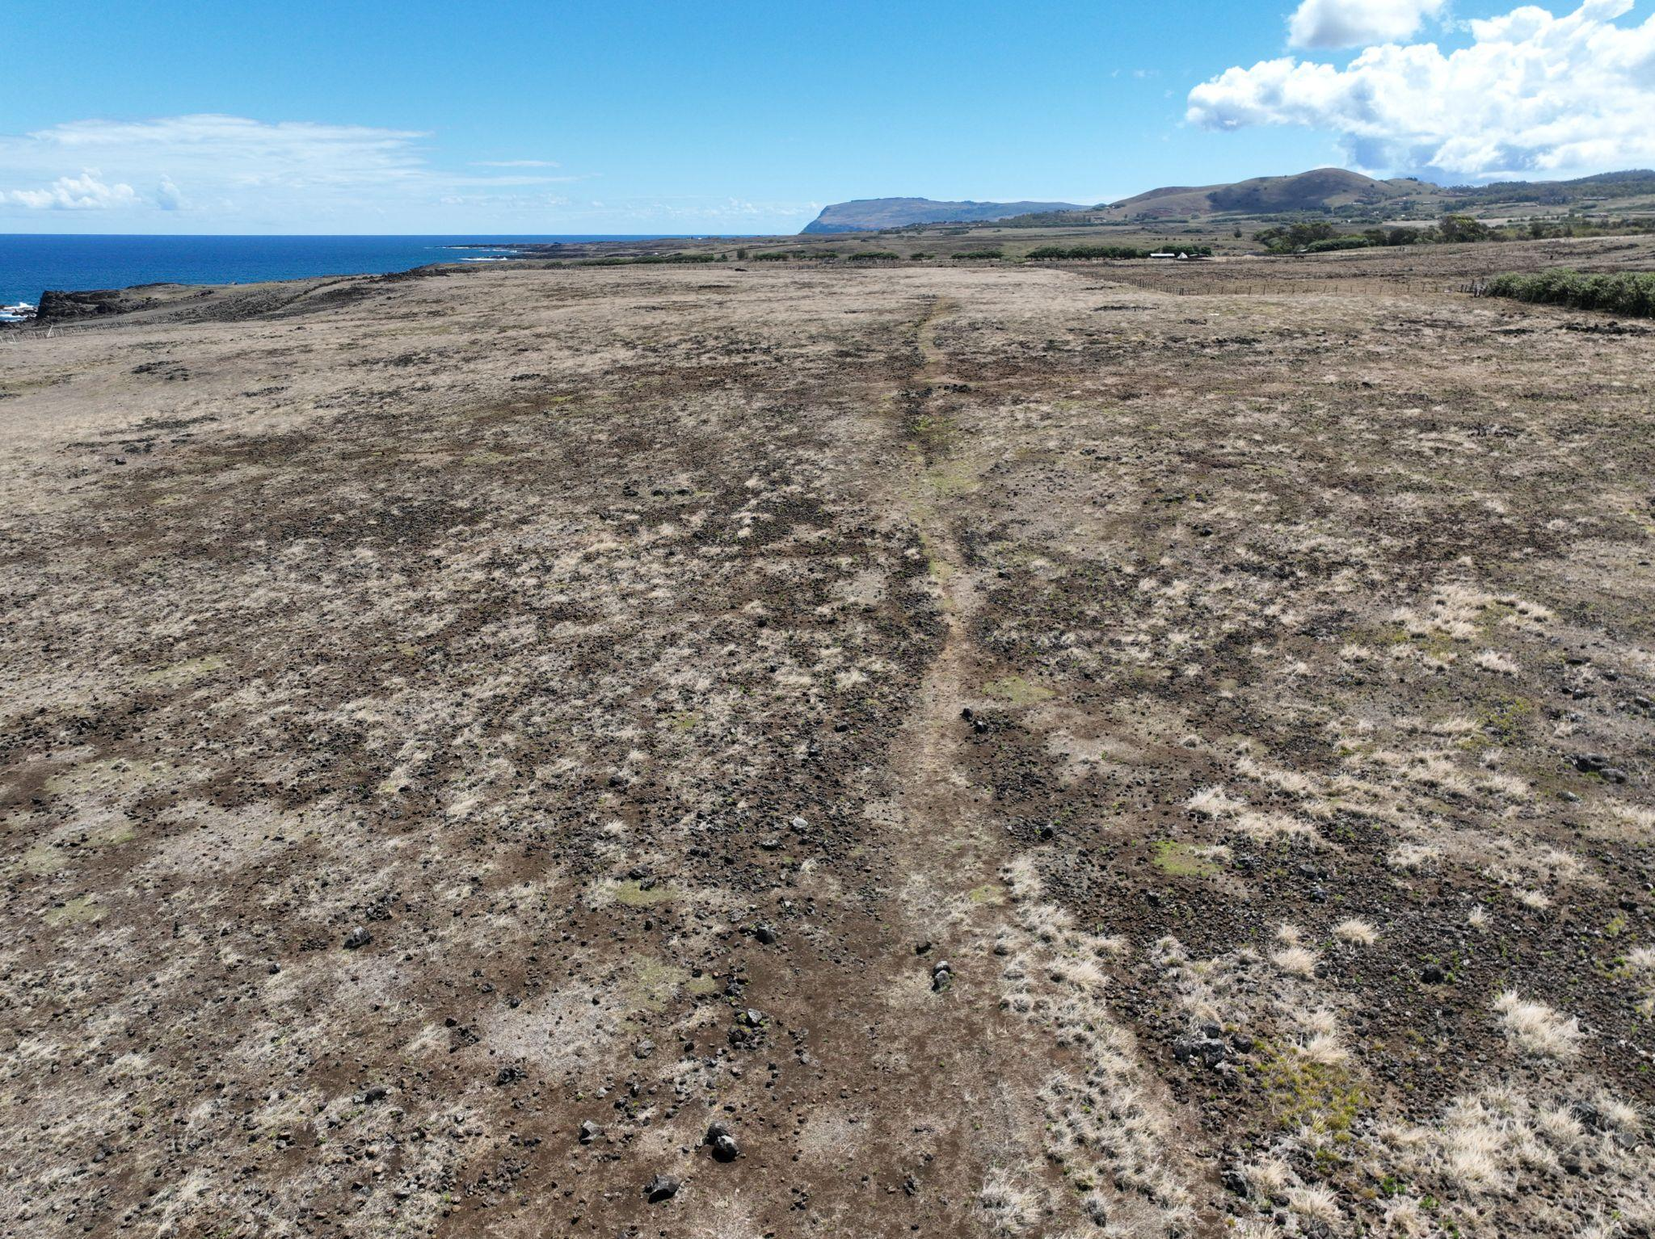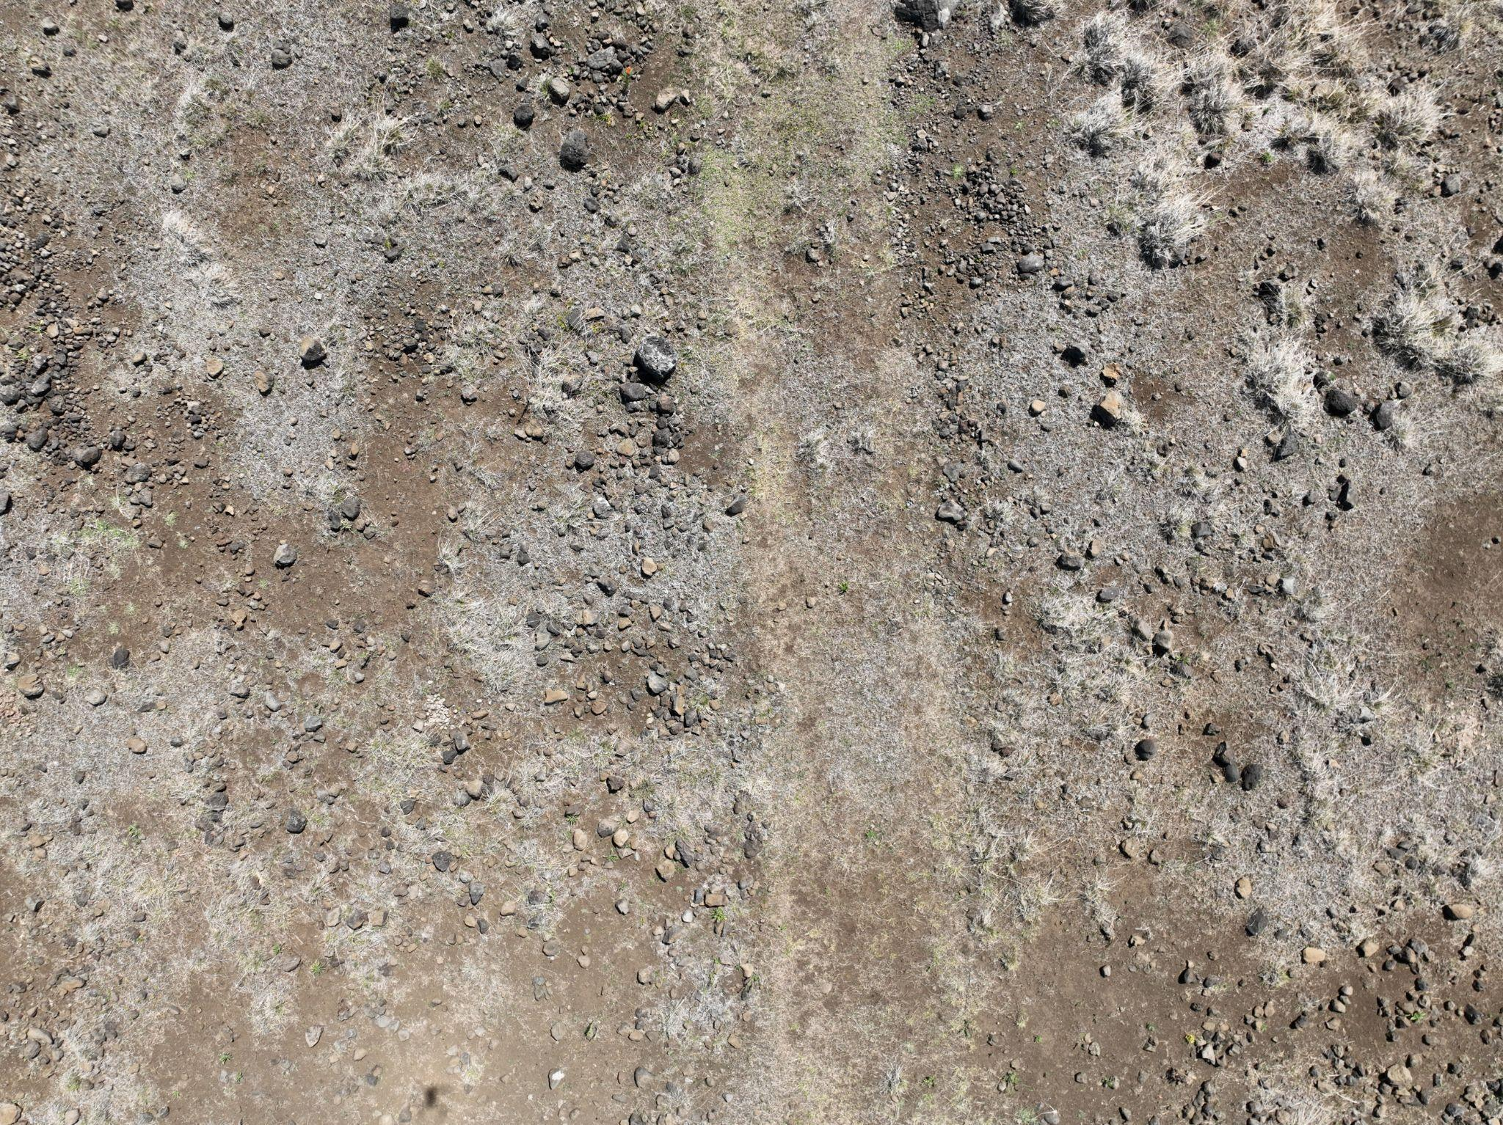
Figure 10. Moai Roads. (Left) Moai road stretching along the south coast. (Right) Detail of moai road. The width of the moai road is ca. 4.5 meters.
Most significantly, the distinctive concave cross-sectional profile of these roads, consistently observed across multiple excavated segments, appears purposefully engineered rather than incidental. Rather than presenting an obstacle to upright transport, as some have suggested, this U-shaped configuration would have served as a critical control mechanism for walking moai. The concave profile would naturally center a rocking statue, preventing lateral drift and helping maintain directional control during the forward-rocking motion. Each step would be guided by the road's geometry, with the curved walls providing both physical constraints and visual alignment cues for the transport teams. This engineering feature transforms what might otherwise be unpredictable movement across rough terrain into a controlled, directed progression along a prepared pathway, precisely the kind of infrastructure one would expect if upright transport methods were indeed the primary means of moving moai across the island.

2.3. Alternative Transport Mechanisms
Based on an argument that the island lacked sufficient resources for making rope (addressed below), Velasco (2019) proposed an alternative horizontal transport method that attempted to address the rope availability problem on Rapa Nui. His model suggests that moai were transported in a supine position on two "propulsion logs" approximately 10 meters in length and 0.35-0.50 meters in diameter. These logs, with recesses carved into their upper surfaces to support the moai's back, would rest perpendicular to a series of wooden rails placed like train tracks, spaced 0.5-1.0 meters apart. The system would function through teams pushing the propulsion logs forward along lubricated rails, with the moai remaining stable throughout transport. For uphill sections, Velasco proposed using levers positioned in the circular holes found alongside roads, arguing these served as fulcrums to multiply force.
However, this model faces several critical limitations. First, the wooden infrastructure required would demand substantial quantities of straight, durable hardwood logs. While Velasco acknowledges the use of Jubaea palm wood, the island's forest composition was dominated by palms rather than the hardwood species typically required for such heavy-duty applications. The small hardwood species identified through archaeobotanical studies (such as Alphitonia and Elaeocarpus) represented only a minor fraction of available timber and would have been insufficient for the extensive rail networks his model requires (Orliac and Orliac, 2008).
Moreover, Love's (2001) archaeological excavations revealed that moai roads exhibit a concave cross-section, either U or V-shaped, which would complicate the placement and stability of Velasco's proposed rail system. While Velasco suggests rails could be positioned in the lower areas of these concave paths, this configuration would create significant engineering challenges for maintaining alignment and preventing lateral slippage under multi-ton loads. Additionally, the presence of pits around the roads is explained as cultivation pits found in agricultural areas (Stevenson et al., 2006, 2007) and pre- or post-dating road use.
Most critically, this horizontal transport hypothesis cannot explain the archaeological evidence observed on the road moai that display consistent forward-leaning postures, dorsal wear patterns, and specific breakage configurations. These features, which serve no functional purpose in horizontal transport, remain unexplained by Velasco's model, as do the mechanisms for the initial horizontal positioning of completed statues and their subsequent erection at ahu sites.

2.4. Nothing new? Building on Pavel’s Pioneering Work and the Critical Morphological Discovery
The walking hypothesis has deep roots in both Rapa Nui oral tradition and experimental archaeology. The Rapanui people have long maintained that their ancestors made the moai “walk” from the quarry, a claim often dismissed by Western scholars as metaphorical or mythological. Pavel Pavel, a Czech engineer, took these oral traditions seriously and, as early as 1982, began arguing for vertical transport based on both ethnographic accounts and his own engineering analysis. In 1986, Pavel conducted the first serious experimental attempt to demonstrate vertical moai transport, working with Thor Heyerdahl and a team of assistants to move a concrete moai replica in an upright position (Heyerdahl, 1989, pp. 240–241). His team successfully demonstrated that a statue could be moved upright using ropes, with the crews performing a “shuffling” or “wiggling” motion. The statue did move forward, validating the basic concept of vertical transport (Pavel 2018, 2021).
However, Pavel’s experiments encountered significant limitations that prevented wider acceptance of the walking hypothesis. His method required substantial physical effort, achieved only limited forward progress (estimated at 100 meters per day under ideal conditions), and, most problematically, caused damage to the statue’s base through friction with the ground. Critics argued that if this method could barely move a statue a short distance without causing severe abrasion, it could never account for transporting it over kilometers of rough terrain.
Our research revealed why Pavel’s experiments, though conceptually on target, struggled practically: he used the wrong form of moai. Pavel’s actual ahu moai, like those in all subsequent experiments, including Van Tilburg’s replica, was based on the form of moai erected on ahu platforms—statues that had already been modified for permanent display. These ahu moai (modified to completion) stand vertically upright (bases flattened) with their center of mass positioned stably over their base, requiring significant force to tilt and producing primarily twisting motion rather than forward movement when rocked.
On road moai, the forward lean positions the center of mass at or slightly beyond the front edge of the base, creating inherent instability that Pavel’s upright statue lacked. When tilted laterally, this forward-displaced mass not only rocks the statue but also causes it to fall forward in a controlled manner. The rounded base edge then acts as a pivot point, allowing the statue to roll forward with each oscillation rather than simply twisting in place. Each lateral rocking motion thus produces a definite forward “step” without the grinding friction that quickly damaged the moai that Pavel used.
The insight into morphology explains why Pavel’s experiments failed to convince skeptics. He was trying to walk a statue specifically engineered to stand still. The modifications made to moai upon reaching an ahu—trimming the base, adjusting the lean, and creating a stable upright stance—were precisely designed for stability, not mobility. Pavel correctly identified that moai moved vertically, but without recognizing the specialized transport morphology of moai, his method appeared impractical for long-distance movement.
Our experimental validation, using an accurately proportioned Rapa Nui road moai replica, vindicated both the Rapa Nui oral tradition and Pavel’s vertical transport hypothesis, while revealing the sophisticated engineering that made such transport practical. Where Pavel’s upright statue required constant force and suffered base damage, our forward-leaning replica, with its curved base, walked smoothly with minimal effort, covering 100 meters in 40 minutes, compared to Pavel’s full-day estimate for the same distance.
The progression from Pavel’s pioneering work to our morphologically informed experiments underscores the need to integrate indigenous knowledge, experimental archaeology, and detailed analysis of variation in form. Pavel deserves recognition for taking oral traditions seriously and challenging the dominant assumption of horizontal transport, a move that invited ridicule from established scholars. His experiments suggested that vertical transport was feasible and consistent with cultural memory. Our contribution builds on this by showing that ancestral engineers intentionally designed statues for walking. These statues were later modified to stand erect on ceremonial platforms, a transformation that effectively erased the morphological features essential for movement. Earlier researchers had overlooked the distinction between road moai and ahu moai.
This discovery transforms our understanding of Rapanui engineering sophistication. The ancient islanders did not move statues upright merely because it was possible; they optimized their morphology for efficient transport. Features such as the forward tilt, curved base, and specific width ratios reflect deliberate adaptations for dynamic walking. Once the statues reached their destinations, these transport features were carved away to create stable, upright monuments. In retrospect, Pavel’s insight appears even more remarkable: despite working with a modified ahu moai, he correctly hypothesized vertical transport. What he lacked was the archaeological evidence revealing just how ingeniously the original walking statues had been engineered.

2.5. The "Spiritual Path" Interpretation
Richards et al. (2011), Seager Thomas et al. (2023), and Cauwe and De Dapper (2022, 2015) present a speculative interpretation of the road moai distribution, arguing that these statues were deliberately positioned along ceremonial paths leading to the "sacred center" of Rano Raraku rather than representing transport failures. Their hypothesis rests on four primary observations: (1) the increased density of statues near the quarry, which they interpret as intentional clustering at a ritual boundary and the consistent outward-facing orientation of road moai, suggesting deliberate positioning; (2) geophysical evidence indicating possible platform structures beneath some statues, which they argue demonstrates permanent installation rather than abandonment; and (3) patterns of weathering of the surfaces of the road moai.

2.5.1. Spatial Positions of Road Moai
To evaluate the first claim quantitatively, we analyze the spatial distribution of road moai and consider whether the pattern is consistent with transport failures versus deliberate ceremonial placement. Transport failures in any system tend to follow predictable patterns: early failures due to defects or inexperience, ongoing random failures resulting from unpredictable events, and potential late-stage failures stemming from cumulative stress (Figure 11). For moai transport, each kilometer from Rano Raraku represents additional stress from lifting, rotating, and "walking" multi-ton statues across challenging terrain (Lipo et al., 2013; Pavel, 1995).
If road moai represent transport failures, we would expect the highest concentration of failures near the quarry, where statues with hidden flaws—such as internal cracks, zones of weak stone, or structural vulnerabilities—would likely fail under initial transport stresses. Simultaneously, transport teams would be learning and refining their techniques, with early procedural errors contributing to failures. As teams mastered the walking method and structurally sound statues continued their journey, failure rates should stabilize.
Conversely, if road moai were deliberately positioned as ritual markers, their distribution should reflect cultural tradition or human intentionality rather than mechanical constraints. However, simply asserting that moai positions are "ritual" because they appear intentional constitutes circular reasoning: we cannot define something as ritual merely by declaring it so. To make meaningful claims about ritual placement, we must first establish clear expectations about what distinguishes intentional positioning from circumstantial abandonment. In the case of moai distribution, this requires identifying placement attributes that result from human activity rather than natural or mechanical processes (Dunnell, 1971).
While an argument for moai as ritual markers may seem intuitively pleasing to account for those near the quarry, it raises critical questions about classification and interpretation. Are statues found at great distances and entirely out of view of the quarry also ritual installations? Where do ritually placed moai end and transport failures begin? How would we know? These questions highlight the fundamental challenge of distinguishing between intentional ritual placement and mechanical abandonment without falling into circular logic.
To answer these questions rigorously, we would need to demonstrate positioning characteristics that cannot be adequately explained by transport failure, topographic constraints, or other mechanical factors; characteristics such as consistent orientations, regular spacing intervals, or systematic relationships to other cultural features that transcend the practicalities of moving multi-ton statues across challenging terrain. The ritual hypothesis must therefore first falsify the null hypothesis that these locations are "natural" outcomes of mechanical failure in the same way that flake scars on lithics are identified as artificial only after determining they cannot be explained by any known natural phenomenon (Barnes, 1939; Peacock, 1991). Thus, we must first evaluate the "natural" expectations for moai distributions before we can identify deviations that might signal ritual intent.
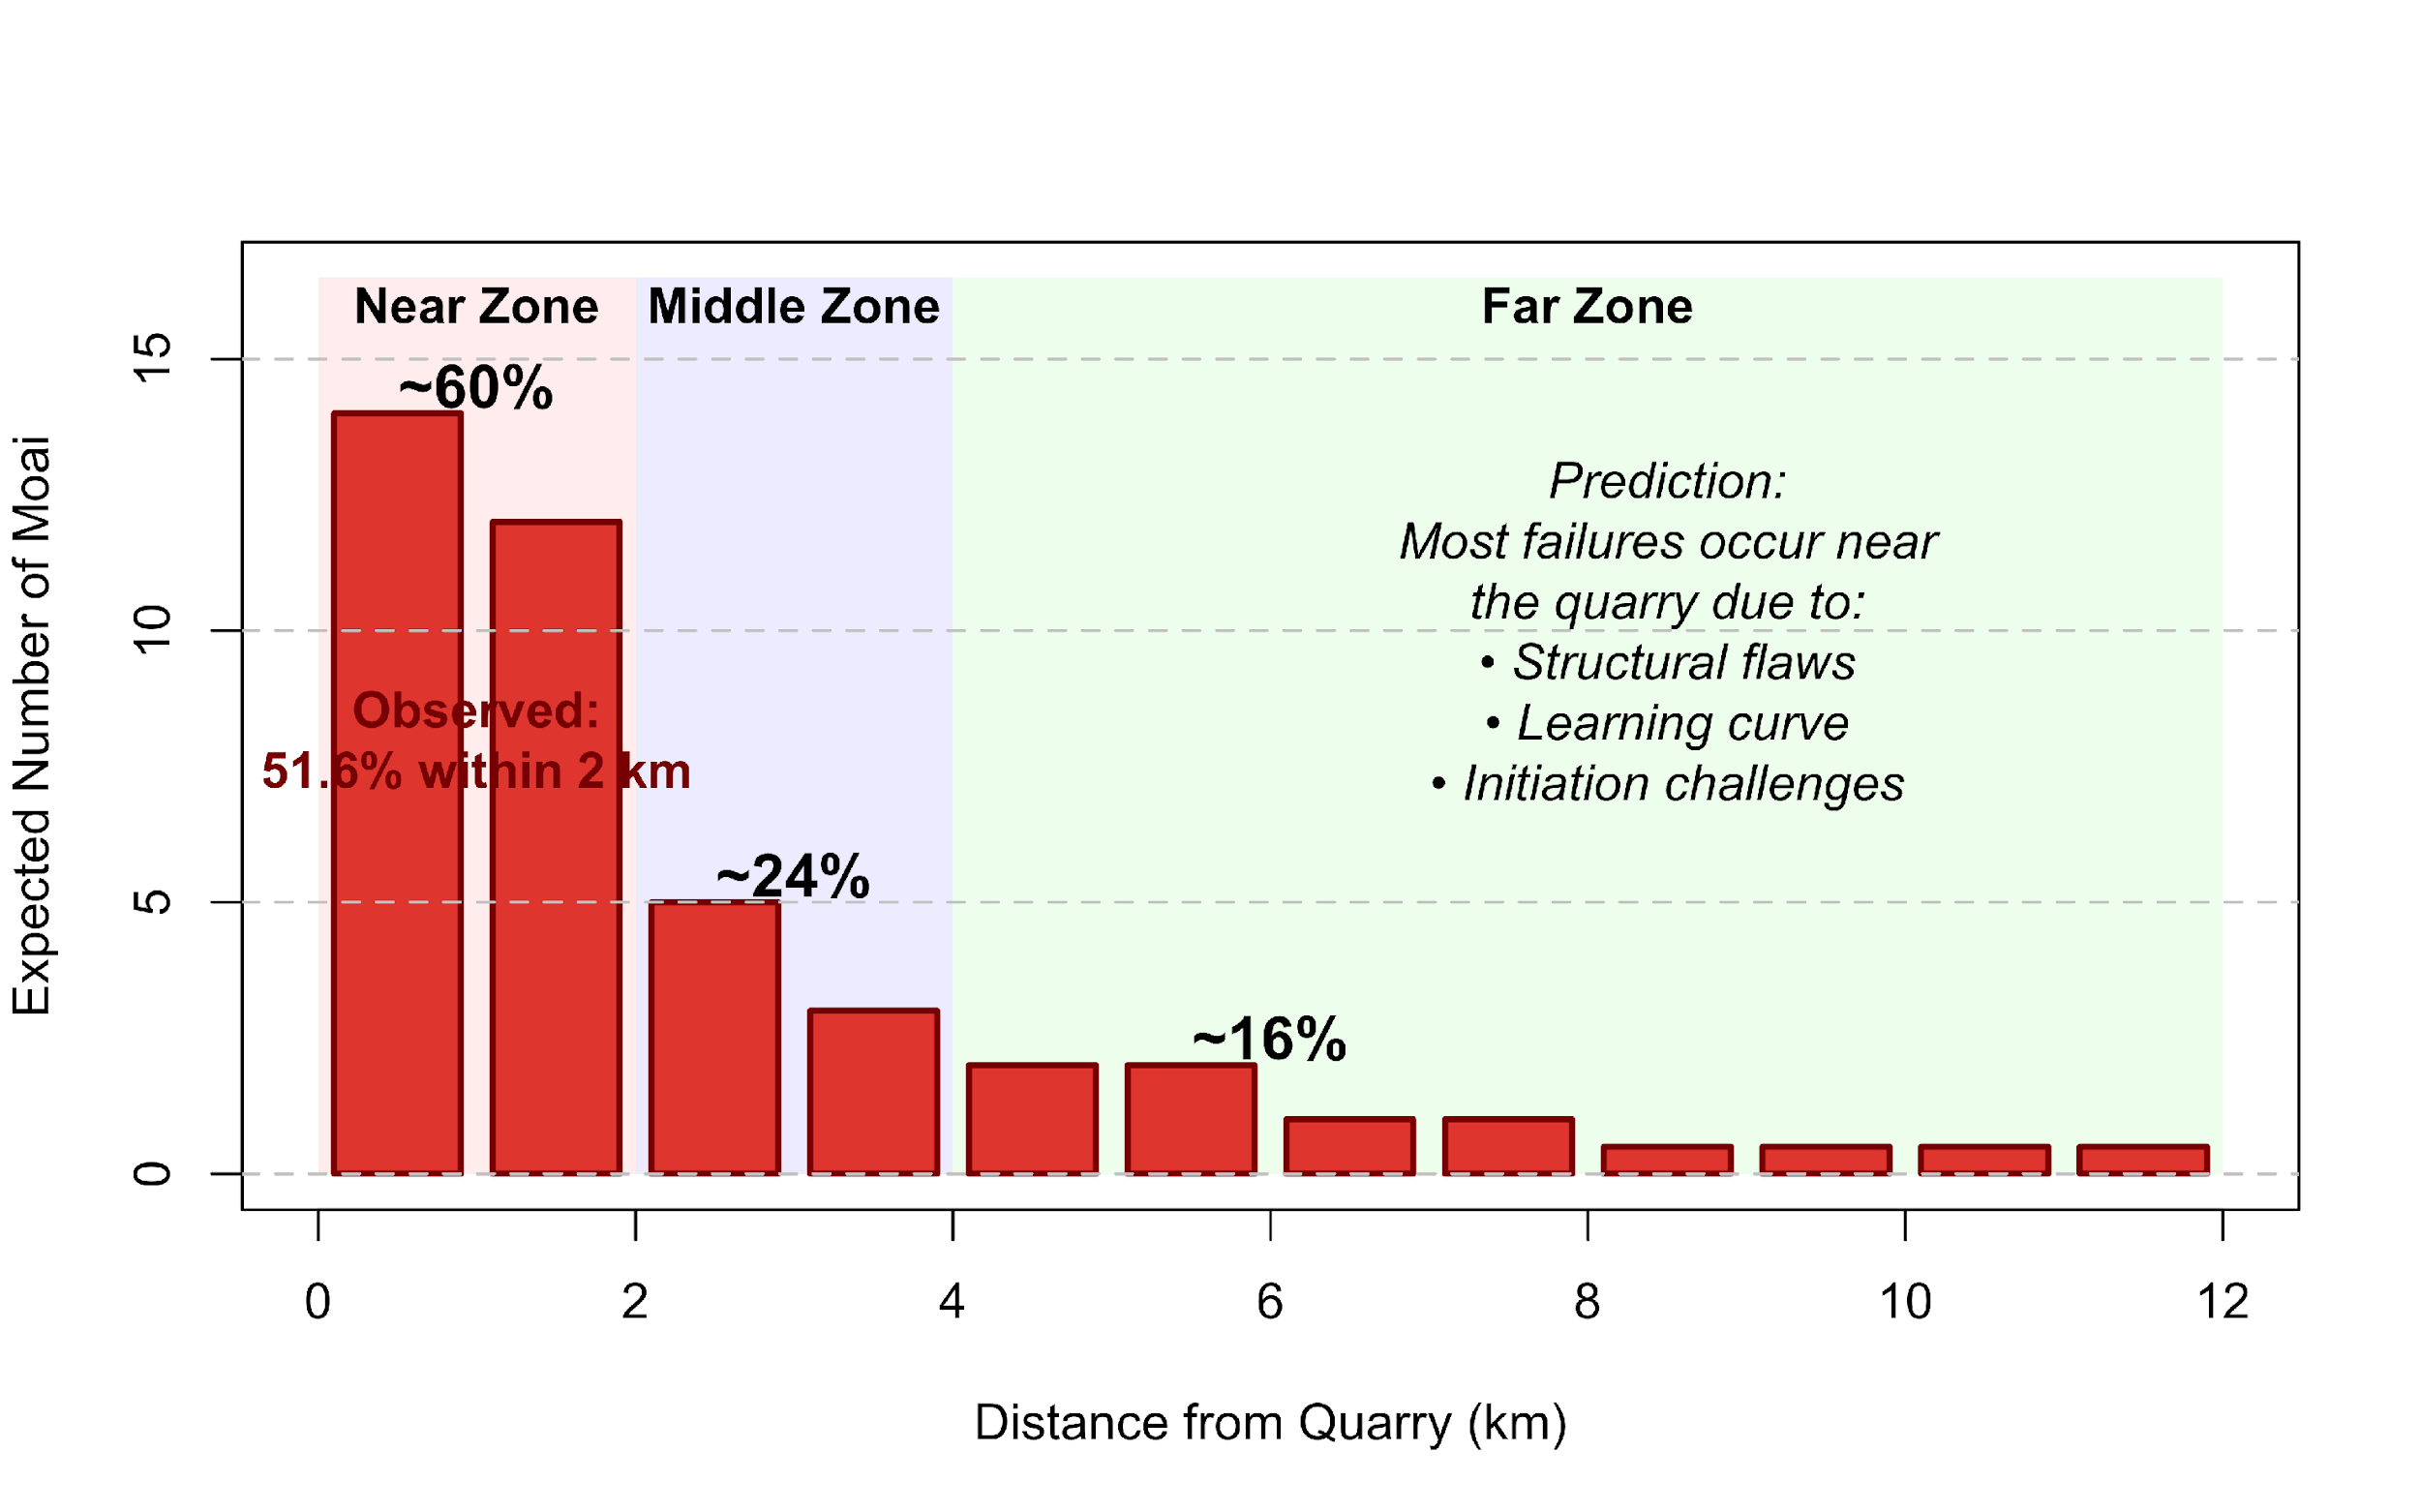
Figure 11. Expected distribution of road moai under the transport failure hypothesis. The histogram shows the predicted spatial pattern if moai locations represent transport failures, based on an exponential decay model where failure probability decreases with distance from the quarry. The three distance zones were derived from this exponential decay function (failure rate ∝ $e^{(0.5×distance)}$), which predicts that initial transport challenges (structural flaws, inexperienced teams, and initiation of movement) would cause most failures near the quarry. Based on the exponential decay function, the model calculates that approximately 60% of failures should occur within the Near Zone (0-2 km, red), 24% in the Middle Zone (2-4 km, blue), and 16% in the Far Zone (beyond 4 km, green). These percentages emerge from the exponential decay model rather than being predetermined categories. The actual observed distribution (Figure 12) can then be compared against these model-derived expectations to test the transport failure hypothesis.

To test competing hypotheses, we developed a quantitative model of expected moai distributions under transport failure conditions. Our transport failure model predicts that failure probability should be highest near the quarry and decrease with distance, following established patterns in materials transport and engineering failure analysis. Critically, this model expects substantial stochastic variation because real-world transport failures involve random factors including variable structural integrity among moai, unpredictable weather and terrain conditions, differences in team experience, and inherent accident probability. We therefore predict: (1) early failures concentrated near Rano Raraku due to structural defects revealed under initial stress and learning-curve errors; (2) exponentially decreasing failure rates with distance as defective statues are eliminated and techniques improve, but with considerable variance around the trend; and (3) high overdispersion (variance >> mean) reflecting the stochastic nature of transport failures.

In contrast, a ceremonial placement model would predict either regular spacing intervals (marking territory or routes), clustering at culturally significant locations (viewsheds, boundaries, intersections), or increasing frequency at distances where quarry visibility is lost. We tested these predictions using comprehensive statistical analyses (Figure S1, see Supplemental Methods).

Our analysis reveals overwhelming support for the transport failure model over ceremonial placement (Table S1). All four statistical tests support transport failure: 79.8% of road moai occur within 3.5 km of the quarry (the approximate viewshed boundary), the coefficient of variation (CV = 2.70) indicates strong clustering near the quarry rather than regular spacing, the exponential decay model is overwhelmingly preferred by AIC (100% model weight versus 0% for uniform or polynomial models), and critically, the moderate goodness of fit (R² = 0.52) combined with high overdispersion (variance/mean = 8.97) confirms the expected stochastic variation rather than deterministic placement. None of the four tests supported ceremonial placement predictions: we found no evidence of regular spacing (Kolmogorov-Smirnov test, p < 0.001), no meaningful clustering at specific distances (nearest-neighbor ratio = 0.80, indicating a random pattern), no increased frequency at the viewshed boundary (density ratio = 1.05), and no statistical support for non-exponential models (Figure S2).
Our analysis of 62 road moai reveals patterns strongly suggestive of transport failure (Figure 12). The most striking finding is the extreme concentration near the quarry: the cumulative distribution function indicates that 50% of failures occur within 1.79 km of Rano Raraku, with 51.6% concentrated in the first 2 km—a concentration that exceeds uniform distribution expectations by a factor of 3.5 (p < 0.001). This extreme clustering near the point of origin is consistent with a failure process rather than intentional distribution. These results also demonstrate that road moai distribution reflects the inherently stochastic nature of transport failure mechanics rather than deliberate ceremonial positioning. The moderate R² value, rather than weakening our conclusion, actually strengthens it by confirming that real-world transport involves the random variation expected from engineering failure processes, distinguishing it from either perfect mathematical models or regular ceremonial patterns.
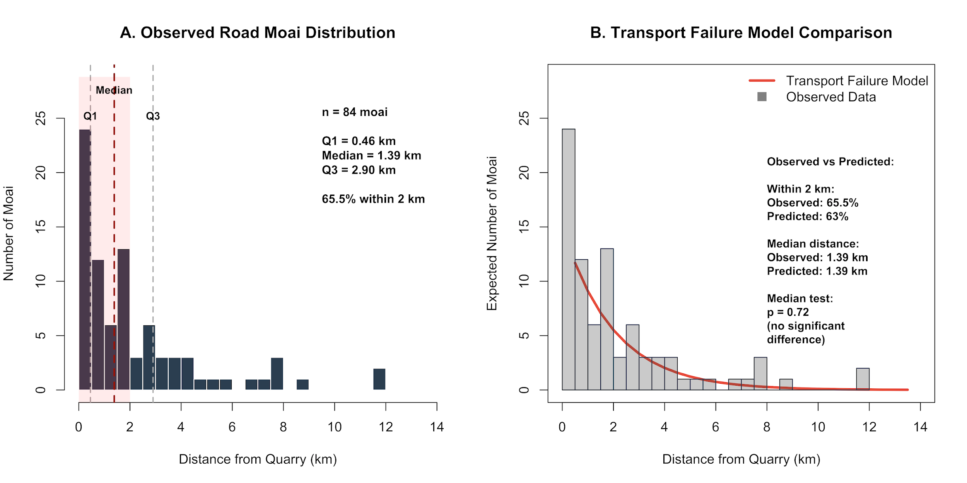
Figure 12. Observed road moai distribution and statistical comparison with transport failure expectations. (A) Histogram showing extreme concentration of 84 road moai near the quarry, with 65.5% within 2 km and 42.9% within just 1 km of the quarry centroid. The quarry center was calculated as the geocentroid of 318 bedrock quarry moai (-27.125175°, -109.288170°), representing the actual center of quarrying activity. Quartile markers indicate Q1 (0.46 km), median (1.39 km), and Q3 (2.90 km) of the distribution. (B) Comparison of observed distribution (gray bars) with transport failure model prediction (red line). The exponential decay model predicts approximately 63% of moai within 2 km, closely matching the observed 65.5%. The high p-value (p = 0.72) indicates no significant difference between the observed median distance and the transport failure model prediction, confirming the close visual alignment. In contrast, ceremonial placement models are firmly rejected (Figure S1, Table S1), supporting the interpretation that road moai represent transport failures rather than deliberate ceremonial placements.
The transport failure hypothesis also generates predictions about the relationship between statue size and failure location. The physics of "walking" a statue depends on maintaining precise balance points, controlling momentum, and managing rotational forces, all of which scale non-linearly with size (Lipo et al., 2013; Pavel, 1995). The gravitational torque (τ) attempting to tilt a forward-leaning statue increases with both height and mass, following the relationship
Eq. 7. $τ=m×g×h×sin Θ$
where m is mass, h is the height of the center of gravity, and $Θ$ is the tilt angle. Larger statues not only weigh more but are taller and have higher centers of gravity, creating a compound effect where doubling statue height can quadruple the toppling forces that transport teams must control (Hunt and Lipo, 2011).
This mechanical reality generates a testable prediction: if road moai represent transport failures, we should observe a negative correlation between statue size and transport distance, with larger statues disproportionately failing near the quarry. Conversely, if road moai represent ceremonial placements, size might correlate positively with distance (important statues placed at significant locations) or show no relationship (size reflecting status rather than transport constraints).
Our analysis of 46 road and quarry moai with complete measurements reveals patterns partially consistent with mechanical constraints. The scatter plot (Figure 13) shows a weak negative correlation between statue size and transport distance (Pearson's r = -0.216, p = 0.149), suggesting size played a limited but observable role in transport outcomes. Mean statue lengths show a moderate decreasing trend: early transport phase moai (0-2 km) average 654 ± 212 cm, middle transport phase moai (2-5 km) average 634 ± 202 cm, and late transport phase moai (>5 km) average 513 ± 177 cm—a 22% decrease in mean size.

The distribution of the largest statues provides additional insight. Of the nine statues exceeding 8 m in length, six (67%) failed within 1.5 km of the quarry, and seven (78%) within 2 km. The remaining two reached only 2.20 and 4.27 km; none achieved distances greater than 4.5 km, despite 8.7% of all analyzed moai reaching such distances. This concentration of large moai near the quarry, combined with the overall weak correlation, suggests that while the walking technique was remarkably versatile and could accommodate various sizes, extreme dimensions did impose practical limits on transport distance, consistent with engineering constraints rather than purely ceremonial planning (Figure 13).
The ceremonial placement hypothesis can also be re-evaluated through size-based analyses. While Figure 13 primarily addresses the size-distance relationship, it provides indirect evidence against the ceremonial placement hypothesis. If road moai represented deliberate ceremonial markers, we would expect either no correlation between size and distance (with important ceremonial locations receiving statues of various sizes based on ritual significance) or a positive correlation (with larger, more impressive statues placed at more distant, important sites). Instead, the weak negative correlation (r = -0.216) suggests mechanical constraints rather than ceremonial planning. The distribution pattern itself (detailed in Figure 12) shows that 42.9% of moai failed within the first kilometer and 65% within 2 km, with numbers decreasing smoothly outward following an approximately exponential decay pattern. This continuous decrease contrasts sharply with the step function or clustering pattern expected if moai were deliberately placed at specific ceremonial distances or territorial boundaries (Richards et al., 2011).
Furthermore, the size data from Figure 13 reveals that the largest statues—those that would presumably hold the greatest ceremonial importance—are concentrated nearest the quarry. Of nine moai exceeding 8 meters, none traveled beyond 4.27 km, despite smaller statues reaching nearly 7.7 km. This inverse relationship between size and achievement contradicts the logic of ceremonial positioning, where the most impressive monuments would mark the most significant locations.
Supported by data from Table 1, the outward-facing orientations of fallen road moai align with the vertical walking transport mechanics, where forward-leaning statues naturally fell in the direction of their travel based on slope when control was lost (Lipo et al., 2013). Combined with the size-distance relationship shown in Figure 13, these patterns strongly suggest transport failures rather than intentional placement.
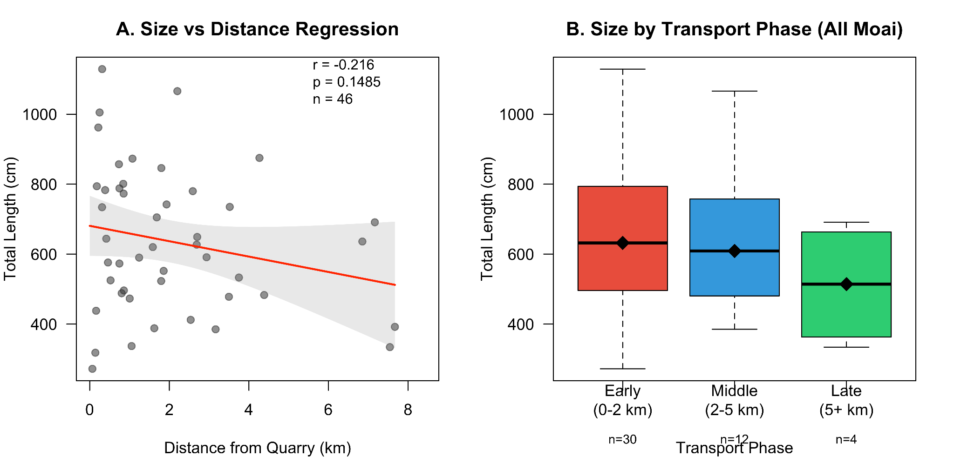
Figure 13. Analysis of moai size in relation to transport distance. (A) Box plots showing size distributions across transport phases, with median values showing a slight decrease from early to late phases. (B) Scatter plot with regression line demonstrating a weak negative correlation between statue size and distance from the quarry (r = -0.216, p = 0.149, n = 46). The shaded area represents 95% confidence intervals for the regression. The lack of a strong correlation between size and transport distance supports the walking hypothesis, suggesting the transport technique was sophisticated enough to move statues of various sizes effectively. The presence of large moai at all distances indicates that statue size was not the primary limiting factor for transport distance, consistent with a versatile and robust walking technique that could accommodate the full range of moai dimensions.

2.5.2. Evidence for Platforms
An additional line of evidence argued to reveal a relationship between the placement of road moai and a broader ritual landscape is the discovery of at least one stone platform during excavations conducted by Skjølsvold as part of the 1955 Heyerdahl expedition (Skjølsvold, 1961). Although the original interpretation linked these features to transport functions, Heyerdahl (1989: 56) later proposed that they may support Routledge’s (1919: 193) earlier hypothesis that moai were positioned upright along a ceremonial pathway leading to the quarry. Richards et al. (2011: 204), drawing on resistivity survey data collected by Croucher (2010), argue that other moai may also rest on similar platforms. However, the geophysical data are inconclusive, as comparable high-resistivity values occur in areas without visible structural remains, raising the possibility that such anomalies reflect natural variation rather than cultural features. Moreover, the presence of platforms does not falsify the walking hypothesis. These features likely represent temporary supports used during transport pauses; evidence for ongoing transport rather than permanent installation.

2.5.3. Weathering Pattern Arguments
Similar to notions of ritual statue placement, Cauwe and De Dapper (2015, p. 16) hypothesize that “isolated” moai were not in transit nor abandoned, but rather the result of voluntary acts, not failed transport. They speculate that the moai stood for perhaps centuries before being carefully laid down. Cauwe and De Dapper make several questionable assumptions, including that moai falling from a vertical position would always break and that at least some of these road moai were observed standing in the 18th century. Other aspects of their argument rely on imaginative speculations not subject to testing or falsification. As a central part of their argument, Cauwe and De Dapper contend that vertical weathering patterns ("runnels") on prone moai indicate extended standing periods before deliberate horizontal placement. They argue these patterns formed primarily from rainfall running down standing statues. Their argument follows earlier speculations made by Routledge (1919, p. 195).
This interpretation of erosion overlooks crucial geological factors and archaeological observations. Moai were carved with hyalotuff bedding planes of the volcanic tuff, which were commonly aligned along the statue's long axis, to minimize the risk of breakage, as fractures tend to follow bedding planes. Since weathering in hyalotuff occurs predominantly in clay-rich bands that swell with moisture absorption (Wedekind et al., 2013), vertical runnels reflect the original bedding orientation, regardless of the transport method or subsequent positioning.
Furthermore, protected surfaces on prone statues, including chest, face, belly, lack runnels, and preserve fine carved details such as hands (Figure 14). These differential weathering patterns indicate post-fall erosion of exposed surfaces rather than pre-placement weathering. Additionally, the statue bases show erosion levels comparable to those of the upper surfaces, suggesting that weathering occurred primarily after the statues fell rather than during extended standing periods.
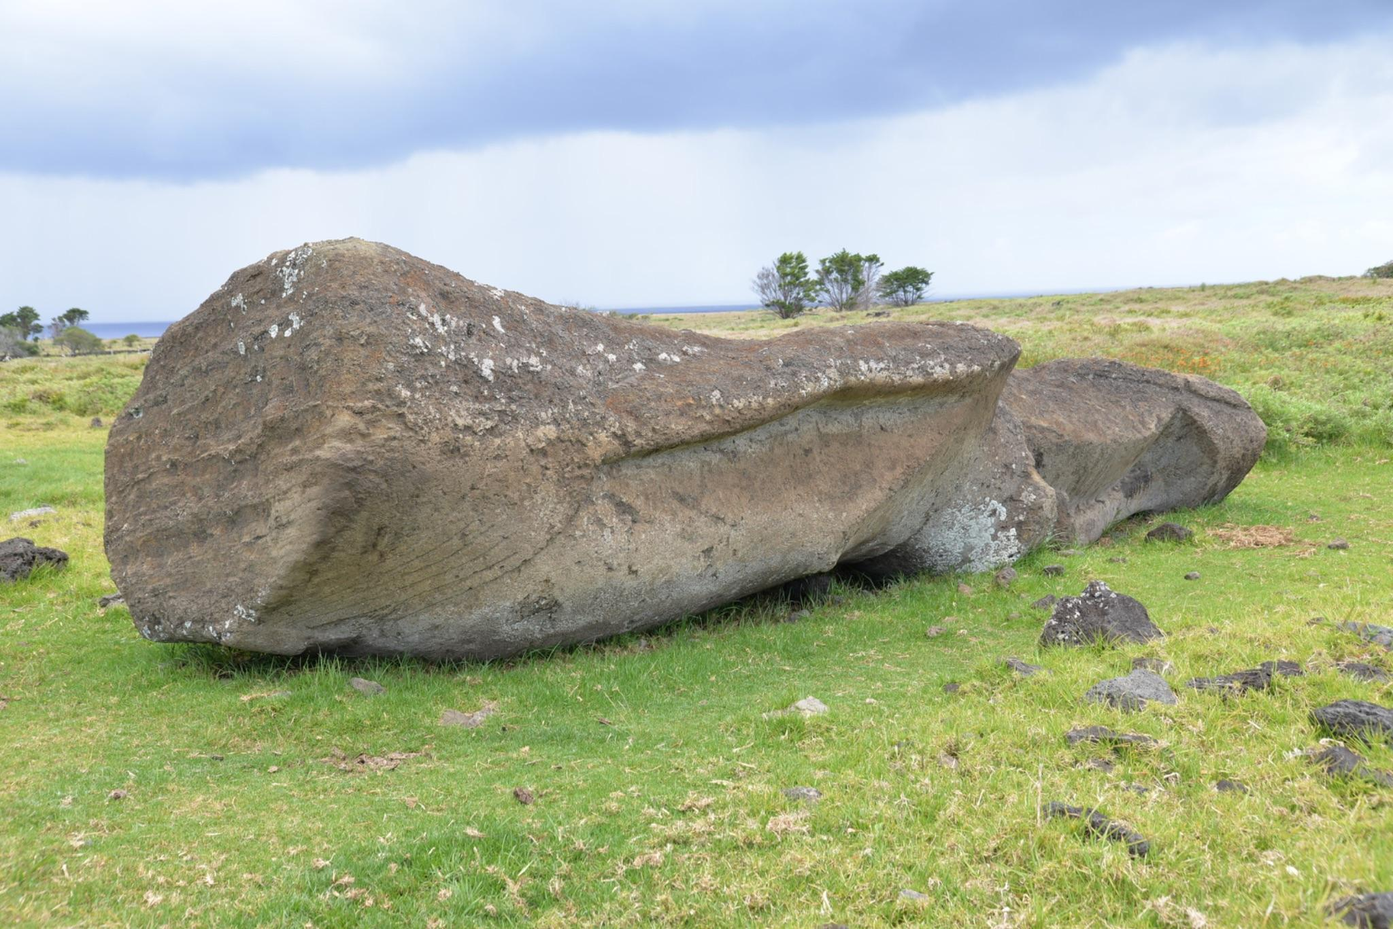
Figure 14. Road moai with erosion runnels on exposed surfaces, back, and base. The protected surfaces are well preserved. If erosion had occurred over long periods while the moai stood, we would expect equal weathering of the front surfaces, which is not evident (note the smooth front and details such as the hand and nipple). Also, note the horizontal bedding at the base of the moai. Horizontal erosion occurs along bedding planes due to varying degrees of consolidation, rather than from the direction of rainwater runoff.

The assumption that unbroken road moai were “carefully laid down” rather than fallen ignores both material properties and archaeological context. While bedding alignment reduced breakage probability, it did not guarantee fracture upon falling. Moreover, architectural features beneath or around moai cannot be assumed to be contemporary with the placement of the statues, as post-transport modifications, including burials and semi-pyramidal ahu construction, are well-documented throughout Rapa Nui (Martinsson-Wallin, 1994).
The position and form of the moai do not provide evidence of a sacred landscape of ritual markers, but rather a record of prehistoric engineering, complete with the learning process and occasional failures that characterize human technological endeavors. The spatial patterns preserved along these ancient paths reveal a history of innovation, perseverance, and ultimate success in one of the ancient world's most ambitious transport projects.

2.7. Rope?
A key requirement for the “walking” hypothesis is that the rope is sufficiently strong that it could be used to rock the moai from side to side. Rope materials were available, and the islanders made ropes for fishing and other household activities (Figure 15). In 1830, Waldegrave (cited in Fischer, 1993, p. 67) visited the island on the HMS Seringapatam and notes: “They had fine lines made from vegetable fibre, exceedingly well-twisted, and nets of very neat workmanship.” Thomson (1891, p. 460) writes that “The coarse nets and cordage was made from the twisted bark of the hibiscus, and the fine ones from the fiber of the indigenous hemp. From the strong, heavy ropes used in raising and transporting the colossal images to the light but durable fish-lines, the threads were all twisted by hand, across the knee, into even strands, which were multiplied according to the size and strength required.”
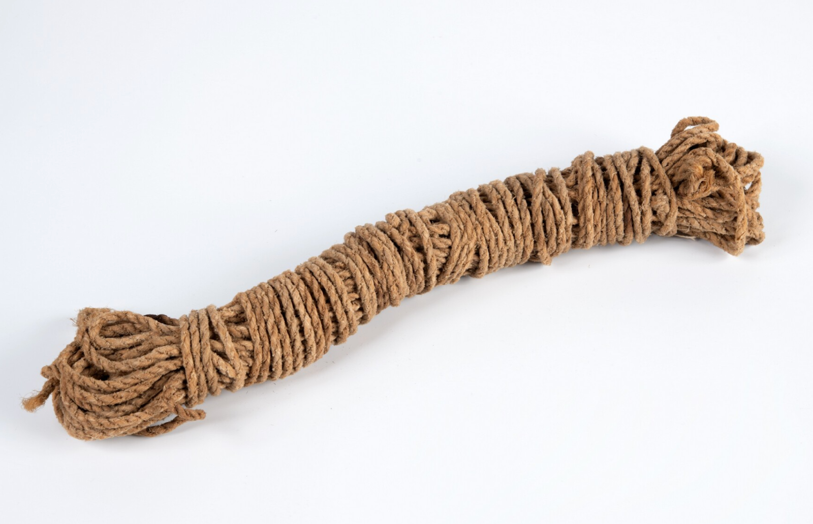
Figure 15. Example of Rapa Nui rope at the Museum Volkenkunde, Leiden. RV-517-13. This work is licensed under a Creative Commons Attribution-ShareAlike 4.0 International License.
Among the plants that provided strong fibers for cordage was hauhau (Triumfetta semitroba), a shrub found on Rapa Nui and across the Pacific Islands (Métraux, 1940, p. 17). In addition, cordage was made from mahute, which is bark from the paper mulberry tree (Broussonetia papyrifera), a small deciduous tree native to East Asia. It was widely cultivated and intentionally spread throughout Polynesia, including Rapa Nui, by early Polynesian voyagers. Both plants were capable of making sturdy cords and ropes. Fine, sturdy cordage and rope are known throughout Polynesia (e.g., Buck, 1957).
Researcher Maureen Folk (2018) examined the “walking with ropes” scenario from an environmental and materials perspective. Her study modeled the amount of cordage needed to move moai upright and the implications for Rapa Nui’s wood resources. Her findings were striking: each statue transported would require roughly three 30-meter ropes, which would consume fiber from an estimated nine large shrubs or small trees, if made using a traditional two-ply twisting method. If a stronger, thicker “composite” rope technique were used, the material required would be about 15–16 shrubs’ worth of fiber per statue. Folk then scaled these experiments up. Based on her estimates, moving more than 400 moai found outside the quarry with new ropes each time could theoretically consume 6,400 trees worth of fibrous plants. However, since moai appear to have been transported across the island for over 500 years, the annual use of shrubs such as hauhau would have been well within their capacity to regrow.

2.7.1. Hauhau and Deforestation?
Collapse proponents have long assumed that the loss of palm forests also resulted in habitat destruction, and thus the loss of hauhau to make rope. Diamond (2005, p. 68) writes that as deforestation progressed, “the islanders ran out of timber and rope to transport and erect their statues.” Diamond’s ecocide narrative suggests that without wood for rollers or strong ropes, statues “walking” (or any other form of transport) became impossible. Flenley and Bahn (2003, p. 164) argue that their pollen data indicate a dominance of hauhau in the earliest (pre-human colonization) layers, but later in the sequence, all trees decline, with nearly complete forest clearance evident in the later layers. Thus, the implication is that once the islanders had no large trees or sufficient fiber plants left, they could not obtain the ropes to transport the multi-ton statues. Velasco (2019) makes a similar argument and uses a presumed lack of material for ropes as the basis of his “rowing” method, as previously described.

2.7.2. Was hauhau unavailable to islanders for rope and cordage making?
Unlike the towering palms that once covered the island, hauhau was a shrubby pioneer plant, well-suited to disturbed landscapes (https://dev.floranorthamerica.org/Triumfetta_semitriloba?utm). It thrived in areas where the soil had been recently turned, whether by natural forces or human activity. Rapa Nui, especially during rapid environmental transformation, would have been an ideal habitat for its growth and expansion. As the palm forests were gradually cleared to make way for cultivation, the conditions became increasingly favorable for hauhau to thrive. While other plants may have struggled in the island’s changing landscape, hauhau would have spread, ensuring that a steady supply of fibrous material remained available for making essential rope. Hauhau never completely disappeared from the island. It grows on Rapa Nui today, and there is no evidence that it was reintroduced from another island. Thus, it is unlikely that Triumfetta was ever eliminated or reduced to the point of precluding rope production in ancient times.

3. Conclusion
The walking moai hypothesis offers a comprehensive explanation of the archaeological evidence, including distinctive statue morphology, road characteristics, breakage patterns, spatial distributions, and weathering features. Experimental replications have demonstrated the feasibility and efficiency of vertical transport, with small teams moving large statues using resources available to ancient Rapa Nui islanders.
When examined systematically, the converging lines of evidence for vertical transport are particularly compelling. The distribution of fallen moai, their consistent breakage patterns, and deliberate morphological features, including forward lean and carefully calibrated center of mass, cannot be accounted for by alternative transport models. The physics of upright movement clarifies the forces involved, while experimental trials confirm the dynamic yet controlled nature of the process. No other hypothesis integrates these factors into a coherent explanatory framework.
Critics have yet to offer plausible alternatives that account for the full range of evidence. Appeals to intuition, selective observations, or misreadings of weathering patterns fall short in explaining the archaeological record. The predictable distribution of road moai, the engineering of statue morphology for walking, and successful experimental replication all point to the same conclusion. Until competing models can account for this body of evidence, the walking hypothesis remains the most robust explanation for one of Polynesia’s most remarkable engineering achievements.
The success of moai transport reveals a sophisticated understanding of physics and engineering among the ancient Rapa Nui islanders. Rather than requiring massive labor forces and environmental destruction, statue transport employed elegant mechanical principles, achieved through careful observation and innovative problem-solving—a testament to Polynesian ingenuity that “walked” into history.

Acknowledgements
We gratefully acknowledge Pavel Pavel for his pioneering work on statue transport, and Sergio Rapu Haoa for his collaboration and deep insight. We also thank Gina Pakarati for her generous support and assistance throughout all aspects of our fieldwork. We are especially grateful to Gina Pakarati and Mike Rapu Haoa for their longstanding commitment to community-based archaeology on Rapa Nui. We further thank the Board of Directors of the Comunidad Indígena Ma’u Henua for their support and for granting permissions. Portions of this research were funded by the National Science Foundation (Award #2218602) and the National Geographic Society.

Data Availability Statement
All data and code necessary for generating the data figures (Figs. 2, 3, 4, 5, 6, 11, 12, and 13) are available at https://orb.binghamton.edu/anthro_data/13/.

References
Alexander, R.M., 2003. Principles of Animal Locomotion. Princeton University Press, Princeton, N.J.
Barnes, A.S., 1939. The Differences Between Natural and Human Flaking on Prehistoric Flint Implements. Am. Anthropol. 41, 99–112. https://doi.org/10.1525/aa.1939.41.1.02a00080
Buck, P.H., 1957. Arts and crafts of Hawaii. Bishop Museum Press, Honolulu, HI.
Callaway, E., 2012. Easter Island statues “walked” out of quarry. Nature. https://doi.org/10.1038/nature.2012.11613
Cauwe, N., De Dapper, M., 2022. Undelivered Moai or Unidentified Monument?, in: Rull, V., Stevenson, C. (Eds.), The Prehistory of Rapa Nui (Easter Island): Towards an Integrative Interdisciplinary Framework. Springer, New York, pp. 205–235.
Cauwe, N., De Dapper, M., 2015. The Road of the Moai, an Interrupted Travelator?, in: Easter Island: Collapse or Transformation? A State of the Art. Royal Academy for Overseas Sciences, Brussels, pp. 9–57.
Chaffin, D.B., Andersson, G.B., Martin, B.J., 2006. Occupational Biomechanics, 4th ed. Wiley, New York.
Diamond, J., 2011. The myths of Easter Island – Jared Diamond responds. Mark Lynas Environ. News Comment. URL https://web.archive.org/web/20190215100417/http://www.marklynas.org/2011/09/the-myths-of-easter-island-jared-diamond-responds/ (accessed 7.22.25).
Diamond, J., 2005. Collapse: How Societies Choose to Fail or Succeed. Viking, New York.
Dunnell, R.C., 1971. Systematics in Prehistory. The Free Press, New York.
Fischer, S.R., 1993. The calling of H.M.S. Seringapatam at Rapanui (Easter Island) on 6 March 1830. Pac. Stud. 16, 67–84.
Flenley, J.R., Bahn, P., 2003. The Enigmas of Easter Island. Oxford University Press, Oxford.
Folk, M., 2018. Evaluating the Environmental and Material Implications of Moai Transport Methods on Rapa Nui. University of California, Berkeley.
French, A.P., 1971. Vibrations and Waves. Norton, New York.
Gioncada, A., González-Ferran, O., Lezzerini, M., Mazzuoli, R., Bisson, M., Rapu, S.A., 2010. The volcanic rocks of Easter Island (Chile) and their use for the Moai sculptures. Eur. J. Mineral. 22, 855–867.
Heyerdahl, T., 1989. Easter Island--the mystery solved. Souvenir Press, London.
Hibbeler, R.C., 2016. Engineering Mechanics: Dynamics, 14th ed. Pearson, London.
Hochstetter, F.T., Haoa, S.R., Lipo, C.P., Hunt, T.L., 2011. A Public Database of Archaeological Resources on Easter Island (Rapa Nui) Using Google Earth. Lat. Am. Antiq. 22, 385–397. https://doi.org/10.7183/1045-6635.22.3.385
Hunt, T.L., Lipo, C.P., 2011. The Statues that Walked: Unraveling the Mystery of Easter Island. Free Press, New York.
Kuhn, T.S., 1962. The Structure of Scientific Revolutions. University of Chicago Press, Chicago.
Laplace, P.S., 1902. A Philosophical Essay on Probabilities. John Wiley & Sons, New York.
Lipo, C.P., Hunt, T.L., 2005. Mapping prehistoric statue roads on Easter Island. Antiquity 79, 158–168. https://doi.org/10.1017/S0003598X00113778
Lipo, C.P., Hunt, T.L., Haoa, S.R., 2013. The “walking” megalithic statues (moai) of Easter Island. J. Archaeol. Sci. 40, 2859–2866.
Love, C., 2001. Excavations on Moai Roads, Easter Island. Easter Island Foundation, Los Osos, California.
Love, C.M., 2001. The Easter Island Moai Roads: Excavation Project to Investigate the roads along which the Easter Islanders over their gigantic ancestral statues (Unpublished Report). Museo Antropológico Padre Sebastián Englert, Hanga Roa, Easter Island.
Martinsson-Wallin, H., 1994. Ahu - The Ceremonial Stone Structures of Easter Island: Analyses of Variation and Interpretation of Meanings. Uppsala University, Uppsala.
McArdle, W.D., Katch, F.I., Katch, V.L., 2015. Exercise Physiology: Nutrition, Energy, and Human Performance, 8th ed. Wolters Kluwer, Philadelphia.
McCall, G., 1994. Rapanui: Tradition and Survival on Easter Island, 2nd ed. University of Hawaii Press, Honolulu.
Métraux, A., 1940. Ethnology of Easter Island. Bernice P. Bishop Museum Bulletin 160, Honolulu.
National Geographic, 2012, Scientists Make Easter Island Statue Walk. YouTube. https://www.youtube.com/watch?v=YpNuh-J5IgE (Accessed 30 August 2025).
Orliac, C., Orliac, M., 2008. Extinct flora of Easter Island, in: Di Piazza, A., Pearthree, E., Sand, C. (Eds.), At the Heart of Ancient Societies: French Contributions to Pacific Archaeology. Département Archéologie, Nouméa, New Caledonia, pp. 197–209.
Pavel, P., 2021. Rapa Nui: 40 years of grappling with the mysteries of Easter Island. Rapa Nui Press, Easter Island.
Pavel, P., 2018. Rapa Nui: The man who made the statues walk. VN Publishing, vel.
Pavel, P., 1995. Reconstruction of the transport of moai, in: Fischer, S.R. (Ed.), Easter Island Studies. Oxbow Books, Oxford, pp. 141–144.
Peacock, E., 1991. Distinguishing between Artifacts and Geofacts: A Test Case from Eastern England. J. Field Archaeol. 18, 345–361. https://doi.org/10.1179/009346991791548645
Perreault, C., 2019. The Quality of the Archaeological Record. University of Chicago Press, Chicago.
Popper, K., 1962. Conjectures and Refutations: The Growth of Scientific Knowledge. Basic Books, New York.
Richards, C., Croucher, K., Paoa, T., Parish, T., Tucki, E., Welham, K., 2011. Road my body goes: Re-creating ancestors from stone at the great moai quarry of Rano Raraku, Rapa Nui (Easter Island). World Archaeol. 43, 191–210.
Routledge, K., 1919. The mystery of Easter Island: The story of an expedition. Sifton, Praed & Co, London.
Ruina, A., Pratap, R., 2015. Introduction to Statics and Dynamics. Oxford University Press, Oxford.
Schumacher, Z., 2013. A geo-spatial database of the monumental statuary (moaj) of Easter Island, Chile (MA Thesis). California State University, Long Beach, Long Beach.
Seager Thomas, M., Hamilton, S., Armstrong, F., 2023. Were the Moai Along Rapa Nui’s Ara Moai (Moai Roads) Standing? The LOC “Moai Roads” Survey, 2010–2017. UCL Rapa Nui Landscapes of Construction Interim Reports, 17 (LOC17) (Unpublished Report). University College London, London. https://doi.org/10.13140/RG.2.2.12068.24968/1
Taylor, J.R., 2005. Classical Mechanics. University Science Books, Sausalito, CA.
Thomson, W.J., 1891. Te Pito te Henua or Easter Island. Smithsonian Institution, Washington, D.C.
Van Tilburg, J.A., 2012. Walking moai and “Levitated Mass.” Easter Isl. Statue Proj. URL https://www.eisp.org/4595/ (accessed 7.5.25).
Van Tilburg, J.A., 1994. Easter Island: Archaeology, Ecology, and Culture. Smithsonian Institution Press, Washington.
Van Tilburg, J.A., 1986. Power and Symbol: The Stylistic Analysis of Easter Island Monolithic Sculpture, PhD dissertation, University of California, Los Angeles.
Velasco, G., 2019. Moving the Moai - A New Theoretical Model, in: Vogt, B., Kühlem, A., Mieth, A., Bork, H.-R. (Eds.), Easter Island and the Pacific: Cultural and Environmental Dynamics. Rapa Nui Press, Easter Island, pp. 301–310.
Wedekind, W., Zink, A., Barthel, S., 2013. Petrographical characterization of Easter Island statue rock. Archaeometry 55, 564–578. https://doi.org/10.1111/j.1475-4754.2012.00694.x

